**Social Care Data Maturity Assessment:   
National Report for Wales**

|  |  |
| --- | --- |
| **Authored by Alma Economics**  **Research commissioned by Social Care Wales** | **June 2024** |







**About the authors**



Alma Economics combines unparalleled analytical expertise   
with the ability to communicate complex ideas clearly.

[www.almaeconomics.com](http://www.almaeconomics.com)

**About the commissioning organisation**



Social Care Wales work with people who use care and support services and organisations to lead improvement in social care in Wales.

[socialcare.wales](https://socialcare.wales/)

Table of contents

Executive summary 1

Background and context to this work 1

What we did 2

What did we find? 3

Recommendations for improving social care data maturity 5

Detailed findings and recommendations 1

Background and context to this work 8

What is a data maturity assessment? 8

The background to this research 8

Benefits of a data maturity assessment 9

What we did 10

Stakeholder engagement and research 10

Questionnaire development and roll-out 11

Reporting 12

Limitations of the research 12

What did we find? 14

Key insights from the data maturity assessment 14

Detailed insights from data maturity assessment 16

The FHIR standard and the pathway to a National Data Resource (NDR) 29

What is the FHIR standard? 29

Insights from the data maturity assessment on FHIR compatibility 30

Recommendations for improving social care data maturity 35

Key enablers for all recommendations 35

General recommendations for advancing social care data maturity in Wales 36

FHIR-specific recommendations 40

Glossary of technical terms 44

Appendix I: What does advanced data maturity look like in an organisation? 46

Appendix II: Detailed summary of data maturity assessment findings 48

Executive summary



# Background and context to this work

## What is a data maturity assessment?

This research focuses on assessing the data maturity of Welsh local authorities in relation to their social care functions. Data maturity refers to an organisation's proficiency in collecting, managing, analysing, and utilising data to achieve its objectives. A data maturity assessment evaluates these capabilities, identifying strengths and areas for improvement to enhance data-related practices.

## The background to this research

In November 2020, a [discovery report](https://socialcare.wales/cms-assets/documents/CRT132463A_WA-National-Data-Strategy-for-Social-Care-Discovery-Report-v1.1-ACCESSIBILITY-NOTES_WEB.pdf) for a strategic approach to social care data in Wales recommended the creation of a comprehensive strategy. Social Care Wales, in collaboration with the Welsh Government and other stakeholders, was tasked with developing this strategy. A [Statement of Strategic Intent](https://socialcare.wales/cms-assets/documents/Statement-of-Strategic-Intent-vFinal-EL3.pdf) was published in March 2021, representing Social Care Wales's commitment to collaborate across the health and care sectors to formulate an inclusive social care data strategy and work towards a data-empowered social care in Wales.

A key vision for social care data in Wales is its integration with the healthcare ecosystem through the [National Data Resource (NDR)](https://dhcw.nhs.wales/national-data-resource/), aiming for cohesive health and social care. The NDR will consolidate electronic health and care records, supporting data sharing across organisational boundaries. The effective integration of social care data into the NDR requires compatibility with the Fast Healthcare Interoperability Resources (FHIR) standards. One of the main aims of this study was to provide a high-level evaluation of local authorities' readiness for the NDR.

## The benefits of a data maturity assessment

Assessing local authorities’ data maturity offers significant benefits to both the authorities and the broader social care sector in Wales. For local authorities, it provides a structured framework to enhance the understanding of data practices within each organisation. Each participating local authority has received a bespoke report that highlights its unique strengths and weaknesses, providing actionable recommendations for making advances in data maturity. For the broader social care sector, the assessment provides insights into collective capabilities and areas for improvement, guiding strategic resource allocation and accelerating readiness for NDR integration.

# What we did

The diagram below outlines the key steps involved in this data maturity assessment, representing the sequence of activities from the outset of the project to final reporting.

**Stakeholder Engagement & Research**

August – September 2023

**Questionnaire Development & Roll-out**

October – December 2023

**Local Authority Data Maturity**

December 2023 – February   
2024

**Results fed back   
to local authorities through individual reports**

February – May 2024

**National Data Maturity Assessment Reporting**

April – May 2024

## Stakeholder engagement and research

At the outset of the project, we conducted scoping interviews with seven local authorities and ten key sector stakeholders. These discussions helped us understand current and potential data usage, data-related processes and technological infrastructures, and sharing practices within social care. Insights from these interviews informed the development of the bespoke questionnaire we designed for local authorities to self-assess their data maturity.

To further inform the definition of the structure and content of the questionnaire, we conducted a comprehensive review of existing data and digital maturity assessment frameworks, analysing their strengths and weaknesses to ensure our toolkit was well-tailored to the specific aims of our project.

## Questionnaire development and roll-out

We developed a data maturity assessment framework incorporating best practices and relevant elements from existing frameworks, insights from the scoping interviews and our review of policy documents. The questionnaire featured targeted questions specific to the social care sector in Wales, an intuitive design, and a mix of multiple-choice and open-ended questions. It avoided explicit scoring to encourage honest self-assessment and was non-technical to be accessible to all respondents.

The questionnaire was structured into six sections: 1) resourcing, skills and capabilities; 2) digital records and data quality; 3) systems and processes; 4) uses of data; 5) data sharing; and 6) leadership, strategy, and culture. Each local authority was expected to complete one questionnaire or two separate ones for children's and adult care if their operations differed significantly. A lead contact in each authority was identified to complete the survey and encouraged to create a team of experts to appropriately answer all questions.

We piloted the questionnaire with three local authorities to refine the questions based on their feedback. The full-scale roll-out began on December 14th, following a launch webinar. Local authorities had five weeks to complete the survey, with extensions granted as needed. We achieved a 100% response rate, with all 22 local authorities submitting their responses, and three authorities completing separate questionnaires for children's and adult care, resulting in a total sample of 25 local authority social care teams.

## R**eporting**

The outcomes of the data maturity assessment are reported in two ways. This report provides an overview of findings from all submitted questionnaires and offers a set of sector-level recommendations. In parallel, individual reports for each local authority social care team have been prepared, providing a comparative analysis of each organisation’s responses relative to the average of all respondents, and tailored recommendations based on each local authority social care team's positioning across the various thematic areas covered by the questionnaire.

# What did we find?

The main insights from the data maturity assessment are summarised below, organised by theme:

## Resourcing, skills, and capabilities

* Local authority social care teams face significant challenges in adequately resourcing and developing the staff skills necessary to collect, manage, and use social care data to its full potential. Fewer than half believed they had sufficient staff with broad data expertise, particularly noting a scarcity of specialised roles such as data scientists and data engineers.
* Less than half of respondents report proactively upskilling staff in data skills, driven largely by resource constraints – with only about one-third reporting that the resources dedicated to training and skill development are adequate.

## Digital records and data quality

* Most local authority social care teams demonstrated robust data collection practices, particularly in core areas such as service user background information and interactions with social care services.
* Local authorities indicated a prevalence of structured data, with the majority of respondents reporting their data as mostly or fully structured across all thematic areas except health and medical history. However, challenges persist in data quality, particularly in relation to the completeness and standardisation of data.
* Local authorities commonly reported engaging in initiatives to promote data quality, evidenced by the widespread use of metrics and tools for ensuring data quality and the presence of dedicated teams. However, less than half of respondents use automated processes for data validation and cleaning, highlighting the potential for further advancement.

## Systems and processes

* Local authority social care teams generally reported they received foundational support from their respective case management systems, with a majority agreeing their systems support essential functions such as providing a consolidated view of client information and facilitating swift access to details.
* The user-friendliness of the systems presents a challenge, with only about a third of respondents agreeing that the interfaces are easy to use and do not require extensive training. Furthermore, responses indicated there is capacity for improvement in integrating advanced features like real-time updates or remote data entry.
* A notable challenge also lies in the integration and interoperability with healthcare systems, as many local authority social care teams struggle with standard data exchange protocols and secure data sharing.
* While workflow and automation capabilities exist, their implementation is uneven, and basic tasks such as data entry and scheduling automation are underdeveloped. Furthermore, responses vary on the scalability and performance of these systems, especially under heavy loads and increasing user demands.

## Uses of data

* Whilst local authorities reported using data to inform strategic planning and adaptability, its use in scenario planning varied, suggesting uneven application in anticipating future demands and adapting to emergent situations.
* Although almost three out of four respondents reported using data to influence policymaking, integration with data from other sectors is less common, which could limit the scope of cross-sectoral insights. Reported collaborations with research organisations and the utilisation of linked data for evaluating service impacts also varied, indicating room for growth in these areas.
* Several challenges hinder the effective use of social care data, including issues with data quality, system functionality, and resource constraints. The lack of time and resources, as well as the considerable effort required to comply with national data requirements due to limited system functionality are major hurdles, alongside difficulties in data integration and analytics capabilities.

## Data sharing

* All local authority social care teams indicated a strong commitment to managing data sharing, with well-defined governance protocols, designated roles for overseeing data sharing activities, and robust security measures in place.
* However, fewer than half reported employing standardised data formats and an even smaller share have adopted advanced technologies to facilitate data sharing.
* The barriers perceived by local authorities as most significant to effective data sharing were incompatible data systems, a lack of resources, the ability to quality assure the data being shared, and the complexities of navigating legal frameworks.

## Leadership, strategy, and culture

* Data was widely acknowledged by local authorities as a core organisational priority, with social care teams viewing their leadership to be effectively communicating the value of data across the board.
* Despite this, only about one out of four respondents reported having a formal, well-documented data strategy, and an even smaller percentage reported updating their strategy to reflect evolving needs. Stakeholder engagement is also low, with only about one-fifth of local authority social care teams engaging external stakeholders to provide input on data strategies and priorities.
* A majority of respondents reported promoting innovation through employing pilots and trials to gauge the effectiveness of data initiatives and pursuing collaborations that seek to enhance the utilisation of social care data.

### Insights from the data maturity assessment on FHIR compatibility

The questionnaire included four key questions designed to provide insights into local authority social care teams’ compatibility with FHIR standards and their readiness to implement the NDR programme. The key findings from this assessment are summarised below:

* Most local authority social care teams are in the early stages of developing robust internal system-to-system data exchange practices. No respondent indicated that these practices are widely adopted across their organisation, and about half reported only basic internal data exchange capabilities.
* Capabilities for data exchange with external organisations show considerable variability. About 50% of local authority social care teams manage only basic data exchanges, while a smaller fraction (16%) has begun to establish more frequent and varied data interactions. Challenges such as a lack of awareness or knowledge about implementing effective data exchange practices remain for 26% of respondents.
* There remains a heavy reliance on manual and semi-structured data formats, such as Excel and Word/PDF, used respectively by 96% and 72% of local authority social care teams to exchange data. Only a small minority (36%) reports adopting fully structured formats essential for seamless data interoperability.
* Key challenges in implementing standardised data exchange include information governance issues and inadequate technological infrastructure, each reported by 52% of respondents. Additional barriers include a lack of prioritisation and funding for data standardisation efforts, as well as widespread gaps in knowledge and training, and limited awareness of options for standardisation.

# ****Recommendations for improving social care data maturity****

Underpinned by the findings from the data maturity assessment, we set out a series of recommendations aimed at enhancing the social care sector's compatibility with the FHIR data standard and overall data maturity. These recommendations include both FHIR-specific actions and broader initiatives to improve data practices across social care organisations.

It is important to note that not all of the suggested recommendations will be feasible to implement against the backdrop of the current status quo in the social care sector in Wales. We highlight below two key enablers for increasing data maturity in social care:

* **Recommendation 1: Additional funding.**

Given the scale of change required and the limited resources at the disposal, it is expected that many of the recommended actions suggested will require additional funding to be committed, especially when improvements in infrastructure are needed.

* **Recommendation 2: Sector-wide coordination.**

Leading organisations, such as Social Care Wales, should coordinate initiatives to improve sector-wide data maturity. This includes conducting research, promoting collaboration, and developing shared resources to avoid duplication of efforts.

## ****General Recommendations for advancing data maturity****

Whilst embedding the FHIR standard will be a key element in the pathway toward the NDR, measures to increase general data maturity within social care organisations will be essential for equipping them with the capabilities to make better use of data. Our recommendations include:

* **Recommendation 3: Expand data maturity assessment to other social care organisations.**

Conduct assessments across all social care organisations to gain a holistic understanding of data maturity and readiness for the NDR. This includes private sector providers and other relevant entities.

* **Recommendation 4: A strategy for improving the sector’s data maturity.**

Building on SCW’s Statement of Strategic Intent, the sector should develop a data strategy and roadmap outlining clear actions to improve data maturity. This should include expected timings, indicators of success, organisations responsible for delivery, and the resources required to deliver each initiative. This strategy should be co-developed with stakeholders and widely communicated.

* **Recommendation 5: Development of individual data maturity action plans.**

Social care organisations should develop their own plans to pursue greater data maturity, informed by sector-wide strategies and individual assessments. These plans should detail timelines, resources, and measures of success.

* **Recommendation 6: Development of a sector-wide data dictionary.**

Establish a data dictionary to standardise definitions of core social care data and define a set of minimum operating data standards. This will help ensure there is a shared understanding of core data across organisations, whilst setting minimum standards in data quality and consistency. The data dictionary should be aligned with the FHIR standard.

* **Recommendation 7: Regular monitoring of data maturity over time.**

Track progress over time through follow-up assessments or a self-assessment tool, allowing for continuous improvement and adjustment of strategies. This monitoring will help measure the impact of new initiatives and identify areas for further focus.

## FHIR-specific recommendations

To facilitate more frequent and higher quality data sharing and promote better interoperability with healthcare, accelerating alignment of social care data with FHIR should be a priority for the sector. Our recommendations for the steps required to deliver FHIR compatibility include:

* **Recommendation 8: Raise awareness of the NDR within the social care sector.**

Increase understanding of the National Data Resource (NDR) programme within the social care sector to secure buy-in and support for the necessary changes. Effective communication should make the technical aspects accessible to non-specialists.

* **Recommendation 9: Detailed FHIR compatibility review (gap analysis).**

Conduct a systems and data “deep dive” exercise to gain a more thorough understanding of the compatibility of social care organisations with FHIR standards. This should include a sample of local authorities of varying levels of data maturity and, ideally, a sample of other social care organisations involved in data sharing.

* **Recommendation 10: A FHIR roadmap and action plan.**

Collaborate to create an action plan for achieving FHIR compatibility, specifying responsibilities, timelines, resources, and measures of success. A multidisciplinary working group should develop and oversee this roadmap.

* **Recommendation 11: Set up of a FHIR working group.**

Establish a multidisciplinary group to oversee the development and implementation of the FHIR action plan. This group should include leaders, decision-makers, and technical experts from the social care sector, with roles and responsibilities clearly defined.

* **Recommendation 12: Investment in FHIR-aligned data systems.**

Work with systems suppliers to align data systems with FHIR standards and provide the necessary functionality for effective data exchange. This can be achieved through both "off-the-shelf" systems and custom in-house development.

* **Recommendation 13: Upskilling of social care staff.**

Increase awareness and knowledge of FHIR standards through targeted training and events, coordinated by a central leading social care organisation. This will ensure that staff understand the principles, benefits, and practical steps for FHIR implementation.

* **Recommendation 14: Shared FHIR resources.**

Develop a set of shared FHIR resources to support local authorities and other social care organisations on their pathway towards FHIR compatibility. This could include a support team, documentation, and guidance to pool expertise and avoid duplication, as well as the development of national, regional, and local FHIR profiles.

Detailed findings and recommendations



Background and context to this work

# What is a data maturity assessment?

## Defining data maturity

Data maturity refers to the level at which an organisation is capable of collecting, managing, analysing, and using data to achieve its organisational objectives. This concept encompasses several dimensions including data quality, data governance, data management practices, analytics capabilities, and the overall culture around data within the organisation. A higher level of data maturity means the organisation is more proficient in these areas, leading to improved efficiency, better decision-making, and enhanced ability to achieve organisational objectives.

## Assessing data maturity

A data maturity assessment is an assessment framework that applies broadly across various types of organisations, including those in the private, public and third sector. Assessing the data maturity of local authorities’ social services departments in Wales means investigating how they harness data to guarantee and improve service delivery, achieve regulatory compliance and support strategic decision-making. This process evaluates the extent to which good data practices are embedded in social care teams, the outcomes of these practices, and the extent to which they enable data to be shared across organisations. Assessing data maturity aims to identify both strengths and areas for improvement, providing insights into where investment and initiatives should be focused to facilitate better utilisation of data.

# The background to this research

## Social care data in Wales

In November 2020, a [discovery report](https://socialcare.wales/cms-assets/documents/CRT132463A_WA-National-Data-Strategy-for-Social-Care-Discovery-Report-v1.1-ACCESSIBILITY-NOTES_WEB.pdf) for a strategic approach to social care data in Wales was published, as a first step towards using data more effectively to drive social care outcomes. The report recommended the creation of a comprehensive data strategy for social care, outlining a unified vision for data collection, management, storage, analysis, and usage. Social Care Wales was tasked with leading the development of a social care data strategy, in partnership with the Welsh Government and other stakeholders. A [Statement of Strategic Intent](https://socialcare.wales/cms-assets/documents/Statement-of-Strategic-Intent-vFinal-EL3.pdf) was published in March 2021, representing Social Care Wales's commitment to collaborate across the health and care sectors to formulate a comprehensive and inclusive social care data strategy and work towards a data-empowered social care service in Wales.

Social care in Wales presents a highly fragmented landscape, with services and support delivered by a multitude of organisations spanning the public and private sectors, arms-length bodies, and charities. These organisations display varied levels of data maturity and different capabilities in utilising the data they collect. This diversity highlights the need for a unified approach to enhance data proficiency across the board.

## Progress toward a National Data Resource

A central vision for the future of social care data in Wales is a deeper integration with the healthcare ecosystem, aiming for a cohesive health and social care system[1], [2]. A key component of this vision is the [National Data Resource (NDR)](https://dhcw.nhs.wales/national-data-resource/), managed by Digital Health and Care Wales, which aims to consolidate electronic health and care records into a single repository. This repository will enable data sharing across organisational boundaries and support secondary uses, such as research through the [SAIL Databank](https://saildatabank.com/). The NDR’s primary goal is to link health and care data to support robust decision-making, reduce inefficiencies, and enhance safety and outcomes for the Welsh population.

The effective integration of social care data into the NDR depends on its compatibility with the Fast Healthcare Interoperability Resources (FHIR), the architecture underpinning the NDR. Current variability in data standards among local authorities, who employ both structured and unstructured data formats, complicates data sharing with health partners and integration into the NDR. This variability underscores the importance of the data maturity assessment in evaluating each local authority’s progress towards achieving FHIR compatibility and readiness for integration with the NDR.

# ****Benefits of a data maturity assessment****

Assessing local authorities’ data maturity in their social care functions offers significant benefits to both the authorities and the broader social care sector in Wales. For local authorities, the data maturity assessment provides a structured framework that aims to enhance the understanding of data practices within each organisation. This approach should not only help the organisation and its staff gauge their current data capabilities but also support them in making good use of data. Each participating local authority has received a bespoke report that highlights its unique strengths and weaknesses, providing actionable recommendations for making advances in data maturity. Empowering social care teams to use data more effectively should lead to data-driven insights, which facilitate more evidence-informed decision-making for the running and commissioning of social care services.

For the social care sector more widely, the data maturity assessment has provided an enhanced understanding of the collective strengths and weaknesses in data collection, management, analysis and sharing across Wales. These insights allow for more strategic allocation of resources, ensuring that investments in data improvements are directed where they can have the most significant impact. Moreover, the assessment accelerates the sector's readiness for integration with the NDR, representing a crucial step towards a seamless flow of information across the health and social care ecosystems. Enhanced data-sharing capabilities lead to greater collaboration between social care and other sectors, enriching the data landscape and supporting more robust, evidence-based decision-making.

What we did

The diagram below outlines the key steps undertaken during the course of this project, representing the sequence of activities from the outset of the project to final reporting.

**Stakeholder Engagement & Research**

August – September 2023

**Questionnaire Development & Roll-out**

October – December 2023

**Local Authority Data Maturity**

December 2023 – February   
2024

**Results fed back   
to local authorities through individual reports**

February – May 2024

**National Data Maturity Assessment Reporting**

April – May 2024

# Stakeholder engagement and research

At the outset of the project, we conducted a series of scoping interviews to deepen our understanding of social care data practices, focusing on current and potential data usage, processes, and sharing between organisations. This initial phase involved discussions with representatives from seven local authorities and ten other key sector entities, including Welsh Government, Care Commissioning Wales, Digital Health and Care Wales, Public Health Wales, ADSS Cymru, the Welsh Local Government Association, CASCADE, Data Cymru, and SAIL Databank.

Interviews with local authority representatives explored a range of topics such as:

* the definitions and types of social care data collected;
* the current IT systems employed along with their strengths and weaknesses;
* data sharing practices and challenges; and
* aspirations for future enhancements in data management and sharing.

Conversations with other organisations varied depending on the specific focus of the organisation, but they generally addressed:

* the purposes of collecting and sharing social care data;
* the perceptions around current data collection and management practices in Wales; and
* the key challenges and potential improvements in data sharing.

These discussions were instrumental in shaping the questionnaire we designed for local authorities to self-assess their data maturity.

To further inform our questionnaire, we conducted a comprehensive desk-based analysis of the most relevant existing data and digital maturity assessment frameworks. This review included general data maturity frameworks like the [Data Maturity Assessment for Government](https://www.gov.uk/government/publications/data-maturity-assessment-for-government-framework) and the [Data Orchard framework for the not-for-profit sector](https://www.dataorchard.org.uk/resources/data-maturity-framework), as well as sector-specific frameworks like the social care digital maturity assessments by the [Local Government Association](https://www.local.gov.uk/sites/default/files/documents/Social%20Care%20Digital%20Maturity%20Assessment%202017%20survey%20findings.pdf) and [Digital Health and Care Scotland](https://www.digihealthcare.scot/app/uploads/2022/03/DHCS-Digital-Maturity-Assessment-Local-Authority-Results_Final.pdf). We examined the strengths and weaknesses of these frameworks, which were invaluable in guiding the design principles, content, and structure of our toolkit, ensuring it was well-tailored to the specific aims of our project.

# Questionnaire development and roll-out

We then proceeded to develop a data maturity assessment framework, building on best practice and relevant elements of existing frameworks, the insights gathered through the scoping interviews, and the analysis of relevant policy documents. Key design principles were:

* **Targeted questioning:** Comprehensive coverage of key data maturity areas relevant to the social care sector.
* **Sector relevant:** Questions tailored specifically to the social care sector in Wales, minimising use of generic language.
* **Intuitive design:** User-friendly survey layout, featuring a mix of multiple-choice and open-ended questions.
* **Avoid explicit scoring:** Strengths and weaknesses can be identified without explicitly scoring and comparing local authorities on their data maturity.
* **Non-technical:** Avoid overly technical topics given knowledge may not sit within the local authority.

By adopting these principles in the design of a bespoke data maturity assessment questionnaire, we aimed to maximise response rate, minimise the burden on local authorities in terms of time and resources, and encourage an honest self-assessment.

The questionnaire was organised into six sections:

1. Resourcing, skills and capabilities
2. Digital records and data quality
3. Systems and processes
4. Uses of data
5. Data sharing
6. Leadership, strategy and culture

This structuring was intended to cover all relevant topics and facilitate the survey navigability, helping local authorities to efficiently complete their self-assessment.

Each local authority was expected to complete one questionnaire, or two separate ones for children's care and adult care if their operations significantly differed between these areas. A lead contact in each authority was identified as responsible for completing and submitting the survey. However, to ensure comprehensive and informed responses, we strongly encouraged the lead contacts to create a team of experts who could respond to all questions appropriately.

Before rolling out the survey full-scale, we conducted a pilot test with a subset of three local authorities. This preliminary step proved beneficial as it allowed us to refine the questionnaire feedback from actual potential respondents, ensuring that the questions were clear and effectively tailored to capture the nuances of data practices within the social care sector.

The questionnaire was rolled out at full scale on 14th December 2023, following a launch webinar where we detailed the questionnaire process and the support available to participants. Local authorities were given five weeks to complete the questionnaire, although several extensions were granted on an ad hoc basis to accommodate specific needs. We achieved a 100% response rate, with all 22 local authorities submitting their responses. Three local authorities opted to complete two separate questionnaires for children's and adult care, resulting in a total sample of 25 local authority social care teams.

# Reporting

The outcomes of this data maturity assessment are reported in two distinct ways. This report presents an overview of findings from all questionnaires submitted by local authority social care teams. In parallel, individual reports for each local authority have been prepared – or two reports for local authorities that submitted separate questionnaires for children's and adult care. These individual reports offer a comparative analysis, showing where each local authority social care team stands relative to the average of all responses across the various thematic areas covered by the questionnaire. This approach highlights the strengths and areas needing improvement for each organisation. These reports are confidentially shared with each local authority, ensuring that the detailed feedback remains exclusive to the respective recipients.

# Limitations of the research

Whilst this research provides a valuable contribution to understanding data maturity in the social care sector, the analysis presented in this report is based on local authority self-assessments, which have natural limitations. Given that the data maturity questionnaire relied on self-reported information from local authorities, there was inherent potential for bias in how questions were interpreted and answered. Despite testing of the questionnaire and measures to encourage candid responses – including avoiding explicit scoring and comparisons – there was scope for differences in the interpretation of each question, which could have had an impact on the consistency and accuracy of the data collected.

The diversity of the social care sector – driven by different infrastructures, processes, cultures, and team structures – also means that practices, terminologies, and processes can vary substantially between different local authorities. While the questionnaire was standardised for all participants, this uniform approach might not fully capture the nuanced differences in how data is collected, managed, analysed, or used across various settings. Efforts were made to mitigate this through comprehensive stakeholder engagement, but the relevance and applicability of certain questions might still have been perceived differently by different respondents, potentially affecting the insights gained from this assessment.

This data maturity assessment covered all 22 local authorities in Wales, although the landscape of organisations using social care data is significantly wider. To gain a full understanding of data maturity in the sector, a data maturity assessment of other organisations (such as private sector providers) would be required.

What did we find?

# Key insights from the data maturity assessment

We summarise below the key insights emerging from each theme of the data maturity assessment questionnaire, highlight overarching conclusions and areas requiring attention across local authorities and their respective data management practices. All findings reported are based on the sample of 25 local authority social care teams that participated in the survey.

## Resourcing, skills, and capabilities

* Local authority social care teams face significant challenges in adequately resourcing and developing the staff skills necessary to collect, manage, and use social care data to its full potential. Fewer than half believed they had sufficient staff with broad data expertise, particularly noting a scarcity of specialised roles such as data scientists and data engineers.
* Less than half of respondents report proactively upskilling staff in data skills, driven largely by resource constraints – with only about one-third reporting that the resources dedicated to training and skill development are adequate.

## Digital records and data quality

* Most local authority social care teams demonstrated robust data collection practices, particularly in core areas such as service user background information and interactions with social care services.
* Local authorities indicated a prevalence of structured data, with the majority of respondents reporting their data as mostly or fully structured across all thematic areas except health and medical history. However, challenges persist in data quality, particularly in relation to the completeness and standardisation of data.
* Local authorities commonly reported engaging in initiatives to promote data quality, evidenced by the widespread use of metrics and tools for ensuring data quality and the presence of dedicated teams. However, less than half of respondents use automated processes for data validation and cleaning, highlighting the potential for further advancement.

## Systems and processes

* Local authority social care teams generally reported they received foundational support from their respective case management systems, with a majority agreeing their systems support essential functions such as providing a consolidated view of client information and facilitating swift access to details.
* The user-friendliness of the systems presents a challenge, with only about a third of respondents agreeing that the interfaces are easy to use and do not require extensive training. Furthermore, responses indicated there is capacity for improvement in integrating advanced features like real-time updates or remote data entry.
* A notable challenge also lies in the integration and interoperability with healthcare systems, as many local authority social care teams struggle with standard data exchange protocols and secure data sharing.
* While workflow and automation capabilities exist, their implementation is uneven, and basic tasks such as data entry and scheduling automation are underdeveloped. Furthermore, responses vary on the scalability and performance of these systems, especially under heavy loads and increasing user demands.

## Uses of data

* Whilst local authorities reported using data to inform strategic planning and adaptability, its use in scenario planning varied, suggesting uneven application in anticipating future demands and adapting to emergent situations.
* Although almost three out of four respondents reported using data to influence policymaking, integration with data from other sectors is less common, which could limit the scope of cross-sectoral insights. Reported collaborations with research organisations and the utilisation of linked data for evaluating service impacts also varied, indicating room for growth in these areas.
* Several challenges hinder the effective use of social care data, including issues with data quality, system functionality, and resource constraints. The lack of time and resources, as well as the considerable effort required to comply with national data requirements due to limited system functionality are major hurdles, alongside difficulties in data integration and analytics capabilities.

## Data sharing

* All local authority social care teams indicated a strong commitment to managing data sharing, with well-defined governance protocols, designated roles for overseeing data sharing activities, and robust security measures in place.
* However, fewer than half reported employing standardised data formats and an even smaller share have adopted advanced technologies to facilitate data sharing.
* The barriers perceived by local authorities as most significant to effective data sharing were incompatible data systems, a lack of resources, the ability to quality assure the data being shared, and the complexities of navigating legal frameworks.

## Leadership, strategy, and culture

* Data was widely acknowledged by local authorities as a core organisational priority, with social care teams viewing their leadership to be effectively communicating the value of data across the board.
* Despite this, only about one out of four respondents reported having a formal, well-documented data strategy, and an even smaller percentage reported updating their strategy to reflect evolving needs. Stakeholder engagement is also low, with only about one-fifth of local authority social care teams engaging external stakeholders to provide input on data strategies and priorities.
* A majority of respondents reported promoting innovation through employing pilots and trials to gauge the effectiveness of data initiatives and pursuing collaborations that could enhance the utility of social care data.

# Detailed insights from data maturity assessment

This section provides an in-depth analysis of the findings from the data maturity questionnaires, including a detailed breakdown of responses across each thematic area to further understand the data practices across local authority social care teams.

## Theme 1: Resourcing, skills and capabilities

The first section of the data maturity assessment questionnaire was aimed at understanding the composition of social care teams within local authorities and whether they have access to staff with data skills and knowledge. It covered topics related to the allocation of personnel, roles and responsibilities to activities related to social care data, as well as the skills and capabilities of the social care teams and the data-related training available to staff and social care professionals.

### Teams and composition

Most local authority social care teams in Wales reported having access to staff with data-centric qualifications such as data analysts (92%) and data/information governance officials (84%), providing core support for data analysis and compliance. However, the presence of specialised roles like data scientists and data engineers was found to be less common, at 32% and 48% respectively, indicating a gap in handling complex datasets and advanced data management, which are critical for sophisticated analytics and data-driven decision-making.

### Allocation of personnel, roles, and responsibilities

The majority of local authority social care teams viewed their allocation of roles and responsibilities for managing social care data as effective, with 72% expressing agreement or strong agreement. The percentage decreased to 56% when considering the staff allocation to support analytical initiatives. Whilst this indicates that general role allocation is adequate in many local authorities, there may be challenges in ensuring sufficient resources and support for analytical data tasks within social care functions.

### Skills and capabilities

Local authority social care teams reported varied levels of data and analytical skills within their teams. Around 60% had a clear understanding of the necessary skills to fully support social care data initiatives, but fewer than half indicated that they have sufficient personnel with broad data expertise (48%) or engage in proactive skill upgrades (44%). Only 32% reported actively seeking external talent to boost these capabilities. However, 58% of respondents viewed that their data skills align well with strategic goals, indicating effective use of existing skills to support broader organisational objectives amongst many local authorities.

### Training for staff and social care professionals

Many local authority social care teams indicated they face challenges relating to resource constraints in data-related training, with only 32% agreeing that the dedicated resources are adequate. The results highlighted that data literacy training programmes are lacking among 60% of respondents. Whilst 40% of respondents reported collaborating with educational institutions to enhance data skills, an equal percentage do not, highlighting inconsistency in engagement with external partners to encourage upskilling. Feedback mechanisms to assess training effectiveness were similarly split, with 40% confirming their presence and 40% indicating the opposite.

## Theme 2: Digital records and data quality

The second section of the questionnaire focused on the data collection practices of local authorities across several key thematic areas, including:

* service users' background information and health data;
* interactions with social care services and outcomes from these interactions; and
* data concerning the social care workforce.

For each area, we explored the extent and structure of data collection and investigated the perceived quality of the data in terms of accuracy, completeness, consistency, and timeliness. We also inquired about organisational approaches to ensuring and enhancing data quality.

The charts below provide a visual representation of the extent of data collection and the structuring of collected data across these areas with the subsequent paragraphs describing the findings in detail.

1. Scope of social care data collection – extent of data collection across key social care data thematic areas by share of respondents
2. Alma Economics Data Maturity Assessment of Welsh Local Authority Social Care Teams (n=25)
3. Structure of social care data collection – degrees of data structuring across key social care data thematic areas by share of respondents
4. Alma Economics Data Maturity Assessment of Welsh Local Authority Social Care Teams (n=25)

## Service user core background information

Local authority social care teams generally demonstrated good data collection practices for service user core background information, with 84% reporting extensive data collection efforts. The data structure was reported to be typically well-maintained, with 96% of data mostly or fully structured. Timeliness in updating and sharing data is reported by about three out of four respondents. However, responses indicate some concerns about the levels of completeness and standardisation in data. Whilst 64% viewed that this data was complete and well standardised, notable percentages disagreed, indicating room for improvement for many local authorities around data consistency and completeness.

## Service user additional background information

Many local authority social care teams reported engaging in collecting additional background information on service users, with a total of 60% reporting doing so extensively, though complete data collection remains low at 4%. Responses indicated that 52% of local authority social care teams typically have mostly structured data in this area, although only 8% reported this to be fully structured, highlighting an opportunity to improve data organisation. Regarding data quality, 72% of respondents reported holding regular accuracy assessments, yet challenges persist, with only 48% recognising their data in this area as being complete and 36% reporting it to be standardised. Timely data was considered by local authorities to be more prevalent, with 64% of respondents ensuring data is frequently updated and shared, demonstrating that maintaining updated records is a priority across many local authorities.

## Health and medical history

Local authority social care teams highlighted varied practices in collecting health and medical history, with 56% collecting it to a moderate extent and 16% to a large extent. Notably, no respondent reported complete data collection, with 4% not collecting health data at all. About 72% reported routinely incorporating NHS numbers into their data collection, with the majority of these respondents (59%) recording them for about 80% of service users. Responses relating to the quality of health data indicate significant areas for improvement, with only about a third of local authority social care teams agreeing that their health data is accurate, consistent, and timely. Completeness of data in this area was found to be a particular challenge, with only 24% of respondents agreeing that this is the case and nearly half (48%) explicitly disagreeing.

## Interaction with social care services

Local authority social care teams largely reported robust data collection efforts around service user interactions, with 96% reporting collecting such data to a large extent or completely. The structure of this data was reported to be relatively developed, with 76% reporting their data as mostly or fully structured. This structural integrity is mirrored in the high levels of agreement on the quality of collected data, with significant majorities of local authority social care teams in agreement that their data in this area is accurate (88%), complete (84%), standardised (72%) and timely (72%), suggesting a strong capability to maintain reliable records on service interactions within many local authorities.

## Outcomes from interaction with social care services

Our findings indicated a solid level of data collection to support the measurement of service outcomes, with 72% of local authority social care teams reporting collecting outcome data to a large extent or completely, though complete data collection is less common, at only 8%. Structuring of outcome data demonstrated variability, with almost half of local authority social care teams reporting partially unstructured or only moderately structured data in this area (20% and 28% respectively). Despite this, respondents reported a relatively high confidence in the accuracy (80%), completeness (68%) and consistency (68%) of their data. However, timeliness received lower agreement (52%), indicating a potential area for improvement.

## Social care workforce

Workforce data was reported to be widely captured across local authority social care teams, with 88% reporting collecting data to a large extent or completely. Questionnaire responses also suggested fairly structured data collection across local authorities, with 75% of respondents reporting it as mostly or fully structured. The quality of workforce data was reported by social care teams to be high in terms of accuracy (88%) and completeness (71%), yet challenges remain in its timeliness (63% in agreement and 13% in disagreement) and standardisation (63% in agreement and 21% in disagreement), which may impact on the identification of timely operational efficiencies and strategic planning within local authorities.

## Data quality assurance and improvement

Local authority social care teams generally demonstrated a committed approach to ensuring and improving the quality of social care data, with 76% using established metrics and tools to evaluate its accuracy, completeness, consistency, and timeliness. A similar percentage reported having dedicated teams focused on data quality, with 80% reporting that they promote continuous initiatives to improve the quality of social care data. Despite these efforts, automation of data validation and cleaning processes was found to be less widespread, with only 36% adopting such technologies, indicating reliance on manual methods. Responses indicated that 60% of local authority social care teams report enforcing standardised data formats to ensure consistency, yet only 52% view that challenges related to data standardisation are actively addressed, indicating possible gaps in achieving widespread data consistency. Moreover, the development of data quality assurance skills among staff also appears to be an area which could be further developed, with only 52% of respondents agreeing that sufficient training and resources are available.

## Theme 3: Systems and processes

The third section of the data maturity questionnaire gathered feedback on local authorities’ case management systems for social care services, including key features and capabilities, and the performance of systems in storing, organising, and analysing social care data.

|  |
| --- |
| Background to social care case management systems in Wales The majority of social care data in Wales is collected, maintained, and managed by the 22 local authorities, each employing electronic case management systems to document operational activities and outcomes. Currently, these authorities employ four different electronic care record systems: WCCIS, PARIS, OLM CareFirst, and OLM Eclipse. Despite some local authorities using the same systems, such as the 15 local authorities utilising the Welsh Community Care Information System (WCCIS), there remains significant variation in how these systems are customised and implemented locally, affecting their ability to effectively utilise and share data.  At the time of writing, the Connecting Care programme is in the process of being implemented, led by [Digital Health and Care Wales (DHCW)](https://dhcw.nhs.wales/), and is intended to replace WCCIS with a new “best-in-class” case management system. |

### Support to social care professionals

Most local authority social care teams reported that their case management systems effectively provide a consolidated view of client information (96%) and allow swift access to service user details (88%), supporting informed decision-making for social care professionals. However, fewer than half of the respondents were satisfied with the systems' capabilities for easy record updating at the point of care (52%), client progress tracking (48%), and scheduling (24%). Features such as remote data entry, real-time alerts, and user feedback collection scored poorly, indicating significant room for improvement in data system capabilities.

### Support to social care or data teams within local authorities

Most respondents reported that their case management systems provide support to social care and data teams, with 92% benefiting from centralised and accessible data repositories, and detailed change logs that enhance accountability. However, capabilities vary across other areas; only 40% of social care teams agreed that their systems have adequate data validation tools, whilst 56% viewed that their systems lack sufficient data analytics tools. Whilst 72% of respondents approved of their system’s facilitation of collaboration and information sharing, there were mixed views in relation to their system’s reporting capabilities – with 60% positive toward custom reporting, but only 44% positive toward features for ensuring compliance with statutory reporting regulations.

### Integration and interoperability with healthcare systems

As shown in the following chart, our findings indicate that local authorities face significant challenges in integrating their case management systems with healthcare systems. Only 28% viewed that their systems support standardised data exchange protocols, and just 32% indicated that their systems can securely and efficiently share client data with external healthcare providers, suggesting concerns around data security and exchange effectiveness. Compatibility with healthcare data formats is reported by 48% of local authorities, while adaptability to evolving interoperability standards was found to be limited, recognised by only 24% of respondents.

1. Integration and interoperability with healthcare systems – Percentage of respondents agreeing or strongly agreeing with the following statements
2. Alma Economics Data Maturity Assessment of Welsh Local Authority Social Care Teams (n=25)

### Security and privacy protection

Local authority social care teams reported strong security and privacy protections within their case management systems. All respondents confirmed the use of industry-standard security measures, including encryption and role-based access. About 83% of respondents also stated that their systems meet GDPR and other regulatory requirements. Regular security assessments are reported to be conducted by 88% of local authority social care teams, indicating proactive vulnerability management. However, only 42% of systems were reported to have robust incident response and breach notification procedures, highlighting an area for potential enhancement to align with data protection laws.

### Task and workflow automation

Local authority social care teams demonstrated mixed capabilities in terms of task and workflow automation within their case management systems. While a substantial 79% reported being able to customise automation rules locally, indicating adaptability, fundamental automation capabilities like scheduling and data entry appear to be underdeveloped, with only 13% agreeing they had automation capabilities in these areas. Opinions on the effectiveness of automation features were mixed, with only 46% believing that these features streamline processes and reduce manual interventions, whilst an even smaller proportion (38%) agreed that automation improves efficiency and reduces the risk of errors.

### Performance and scalability

Local authorities exhibited moderate satisfaction with the performance and scalability of their case management systems. Around 75% of respondents confirmed that their systems can handle high user traffic and are rarely down or out of service. A smaller percentage (67%) were satisfied with their system’s ability to manage large data volumes and maintain performance under heavy loads. Confidence in systems' scalability was found to be less certain, with just above half (54%) confident in their capacity to adapt to growing needs. The management of system updates and maintenance by suppliers also received mixed reviews, highlighting this as an area for improvement.

### Training and support available

In the area of training and support relating to social care case management systems, the majority of local authorities reported generally positive results, with 88% of respondents agreeing that their organisation provides readily accessible user manuals and documentation, and the same percentage finding the helpdesk and support team services to be effective. About 79% of respondents viewed that the level of training provided is adequate and updated regularly. However, the user-friendliness of the systems was identified as a substantial challenge, with only 33% agreeing that the interfaces are easy to use and do not require extensive training.

### Feedback collection and integration

The majority of respondents (63%) reported having established systems or protocols for collecting feedback on usability and functionality of the systems, with 79% notifying users of changes based on their feedback. However, only half reported that this feedback is systematically reviewed and incorporated into system updates. The approach to ongoing user engagement, such as through surveys and feedback sessions, revealed division among social care teams in their capabilities, as an equal percentage (46%) agree and disagree on the effectiveness of these practices.

### Disaster recovery

Local authority social care teams reported strong disaster recovery preparedness, with 91% conducting regular data backups, including off-site storage. A vast majority (87%) also reported having implemented redundancy and failover mechanisms to minimise downtime during system failures. Robust disaster recovery plans were reported to be maintained and regularly tested by 83% of respondents, demonstrating thorough readiness. About 74% of social care teams reported having clear data recovery protocols in place, detailing timely restoration and service resumption to quickly address data loss incidents.

## Theme 4: Uses of data

The fourth section of the questionnaire was aimed at investigating the ways local authority social care teams utilise the social care data they collect for a range of purposes, from statutory compliance and capacity planning to improving the service effectiveness, forecasting future demand, and providing insights for policymaking. A series of questions also explored the key challenges local authorities face in effectively using social care data.

### Statutory compliance

Almost all local authority social care teams (96%) agreed that social care data supports their efforts to meet statutory reporting requirements, highlighting its critical role in ensuring transparency and compliance with regulatory standards.

### Capacity planning and case allocation

Most local authority social care teams reported using social care data for capacity planning and case allocation, with 88% indicating use of data to prioritise and allocate cases based on urgency and complexity, and 76% ensuring that social care services align with local demand and that care providers are not overburdened. While a majority (60%) reported leveraging data for developing models that prioritise preventive measures, this area demonstrates room for growth amongst some local authorities, indicating the potential to develop more proactive interventions through data-driven approaches.

### Service effectiveness and improvement

Local authority social care teams largely reported effective use of social care data to enhance service delivery and intervention strategies. The majority (76%) reported utilising data analysis to effectively target interventions, and a similar percentage confirmed its use in evaluating the efficiency of resource allocation. About 72% reported using social care data to monitor service quality and ensure standards are met, although fewer respondents (56%) reported using data to assess early intervention and prevention programmes, indicating potential areas for expanded use of data to proactively improve services.

### Adaptability, capacity building and demand forecasting

Local authority social care teams generally recognised the critical role of social care data in strategic planning and adaptability, with 84% reporting using data to evaluate service provision needs. A significant 72% reported employing data to forecast future demand. However, only 60% viewed it as pivotal in adapting to changing demographics and unexpected events, indicating potential gaps in fully leveraging data for this purpose. The adoption of data for scenario planning and crisis readiness was also less consistent across local authorities, with only about half of respondents (52%) using data for scenario planning, and 64% for crisis preparedness.

### Broader insights for policymaking

The majority of local authority social care teams recognised the importance of social care data in shaping policy and broadening insights, with 72% using it to provide evidence for policy decisions aimed at enhancing community welfare. However, fewer than half (48%) reported integrating social care data with data from sectors like education or housing, suggesting scope for improvement in the development of cross-sector insights. The prevalence of collaboration with external research organisations was also found to be mixed, with 52% of respondents partaking. Whilst 60% of local authorities reported supporting operational and strategic decisions with locally gathered evidence, the use of linked data in research to understand service impacts was found to be less common, with just 32% partaking.

### Challenges and barriers to the use of data

Local authorities reported several significant challenges in utilising social care data effectively, with prominent issues centred around resource constraints, system functionality, and data quality. The most critical issue was found to be a lack of time and resources inhibiting meaningful data-related work, with 32% of respondents viewing it as a major to severe challenge. A substantial concern was also the time and effort required to meet national data requirements given limited system functionalities, with 64% of respondents identifying this as a moderate to major challenge. Data inconsistency across multiple systems, challenges in standardising data formats, and insufficient data quality and accuracy were also identified by local authorities as notable concerns, complicating decision-making and data integration. These challenges highlight the need for better resource allocation, enhanced system capabilities, and improved data governance to fully leverage social care data within local authorities.

The following chart presents the distribution of responses provided by local authorities in relation to the challenges to the use of data presented in the questionnaire, ordered by severity.

1. Barriers and challenges to the use of social care data – perceived severity of key potential challenges by share of respondents
2. Alma Economics Data Maturity Assessment of Welsh Local Authority Social Care Teams (n=25)

## Theme 5: Data sharing

This section of the questionnaire explored local authorities’ data-sharing practices, identifying the organisations with which local authorities share social care data and the purposes behind these exchanges. It further examined organisational approaches and practices surrounding data sharing, as well as the challenges local authorities encounter when sharing data with external stakeholders.

### Overview of the data sharing environment

Local authority social care teams reported sharing data with a broad spectrum of organisations. All reported sharing data with the Welsh Government and the NHS, with the vast majority also engaging in data sharing with other local authorities, the police and law enforcement agencies, legal services and courts, private care providers, and voluntary organisations, demonstrating a commitment to collaborative data practices. It is unclear how much of this data sharing is ad-hoc compared with systematic sharing through automated processes.

Responses highlighted that data is primarily shared to meet statutory requirements, with other significant purposes including evaluating social care initiatives, coordinating emergency responses, and improving the integration of social care with other public services. Most respondents also reported exchanging data to inform early intervention and prevention strategies and support research efforts. Almost all local authority social care teams (96%) confirmed being signed up to the Wales Accord on the Sharing of Personal Information (WASPI).

### Data sharing in practice

All respondents indicated that they have well-defined governance protocols and designated roles for overseeing data sharing activities, ensuring clear accountability and structure. Robust security measures were also reported to be widely adopted, with 96% of respondents ensuring the protection of social care data when shared externally.

All local authority social care teams agreed on having a clear understanding of the challenges to data sharing, although areas for improvement emerged from their answers. Fewer than half of respondents (48%) reported using standardised data formats, with only 36% having implemented advanced technologies for this purpose. Investment in new technologies was also found to be limited, with only 40% reporting actively investing to enhance data sharing efficiency. Whilst 56% of respondents reported having existing partnerships to improve data sharing, only 28% reported actively seeking feedback to improve the quality and usefulness of shared information. This suggests that whilst the foundations of effective data sharing are partially established across some local authorities, further enhancements in standardisation and technology adoption could improve the efficacy and impact of this practice.

### Challenges and barriers to data sharing

Local authorities reported a wide spectrum of challenges to effective data sharing, with different and incompatible systems across organisations cited as the most severe. Almost two-thirds of respondents (64%) indicated that this poses a major or severe obstacle in achieving uniform data-sharing practices. As the second most pressing challenge, 48% of local authority social care teams reported that inadequate resources – including funding, infrastructure, and skilled personnel – represent a major barrier to effective data sharing.

Around 32% of respondents reported facing major challenges in ensuring the quality of shared data, directly affecting the reliability of information exchange across organisations. Legal complexities were also reported as significant obstacles to data sharing, with 72% encountering moderate or major challenges navigating GDPR and other data protection laws and regulations. About 36% of local authority social care teams reported the absence of common identifiers as a major barrier, hindering their ability to link datasets effectively. These issues collectively underscore the need for enhanced standardisation, resources, and legal clarity to foster more robust and reliable data-sharing frameworks within social care.

The chart below displays the distribution of responses from local authority social care teams relating to the challenges to data sharing, ranked in order of severity.

1. Barriers and challenges to data sharing – Percentage of respondents indicating the perceived severity of key potential challenges
2. Alma Economics Data Maturity Assessment of Welsh Local Authority Social Care Teams (n=25)

## Theme 6: Leadership, strategy, and culture

The last section of the questionnaire explored the strength of data cultures within local authority social care teams, examining the influence of leadership, the implementation of data strategies, and the levels of consultation with external stakeholders and experts. It also investigated prevailing attitudes towards innovation and collaboration in the use of social care data, providing an understanding of how these elements contribute to enhancing service delivery and outcomes in social care.

### Data culture and leadership

Local authority social care teams generally acknowledged data as a core organisational priority, with 88% recognising the important contribution of data to effective delivery of social care services. Awareness of the importance of social care data among staff outside of the data teams varied: 60% of respondents agreed that there is broad awareness of the pivotal role of data throughout the organisation, whereas 20% explicitly disagreed. A large majority of respondents (92%) viewed that their organisation’s leadership consistently communicates the importance of data in meeting overarching goals. Integration of a data strategy and principles into daily operations was found to be less uniformly recognised, with 60% of respondents in agreement that this was prevalent. Despite this, a strong majority (88%) indicated widespread understanding of data-sharing protocols, ensuring staff confidence in handling data requests.

### Data strategy and stakeholder engagement

Based on the findings from this data maturity assessment, many local authority social care teams lack a formalised data strategy, with there being more room for more extensive consultation with external stakeholders – including service users, care providers, and other relevant organisations in the sector – to support the advancement of data practices and capabilities. Only around one in four respondents reported having a formal, well-documented social care data strategy, with an even smaller percentage (12%) reporting that they conduct regular assessments and updates of their data strategy. Around 40% of respondents indicated having formal mechanisms in place for incorporating stakeholder voices into data-related decision-making, with only 20% of social care teams agreeing that they engage with stakeholders to provide input on data strategies and priorities.

### Data-related collaboration and innovation

The prevalence of data-related collaboration and innovation amongst local authorities was mixed, with signs that some local authorities are proactively seeking out collaborations and testing new innovations in data practices. Whilst 68% of respondents indicated leadership fosters a culture of innovation and experimentation, only around half (56%) reported actively seeking collaboration opportunities to utilise social care data more effectively. More promisingly, 68% of respondents reported using pilots, trials, and research to evaluate the effectiveness of social care data initiatives, with a further 64% of local authorities reporting participating in collaborative data-sharing initiatives to enhance overall social care data capabilities.

The FHIR standard and the pathway to a National Data Resource (NDR)

# What is the FHIR standard?

This research has been conducted in the context of the ongoing development of the NDR, a shared national resource of health and social care data in Wales. Some of the main challenges historically faced by the social care sector with respect to systematic data sharing are that data is dispersed across many organisations, with different systems being used and there being no standardised format for social care data. Whilst much of the data collected by local authorities is structured, a lot of unstructured data is also collected by local authorities (text, unstructured documents, images), which presents further challenges for systematic data exchange.

The FHIR (standing for Fast Healthcare Interoperability Resource) standard helps to overcome these challenges by providing organisations with a recipe or blueprint for easy data exchange (interoperability), one which, importantly, does not require organisations to record data in the same way or use the same systems. FHIR is the standard which underpins the NDR. It is a standardised data format which can be applied to all health and social care data, as published by [HL7](https://www.hl7.org.uk/), a not-for-profit international standards body.

## Key considerations for compatibility with the FHIR standard

Whilst a detailed audit of local authority social care data practices would be required to fully assess FHIR capability, data collected through this data maturity assessment did provide indicative insights into current levels of alignment of local authority data processes and practices with FHIR. Our initial scoping interviews indicated a very low awareness of FHIR amongst local authorities. Therefore, the data maturity exercise focused primarily on self-assessing some of the building blocks underpinning FHIR standards to provide an indication of the progress that would need to be made to develop the NDR. These building blocks included:

* The nature and scale of data sharing between organisations.
* The extent to which recorded data is structured, as opposed to fully or partially unstructured.
* The extent to which recorded data is standardised, through understanding formats used for data exchange.
* Barriers to data exchange.

# **I****nsights from the data maturity assessment on FHIR compatibility**

The questionnaire included four key questions designed to provide insights into local authority social care teams’ compatibility with FHIR standards and their readiness to implement the NDR programme. The key findings from this assessment are summarised below:

* **Internal data exchange capabilities.** Most local authority social care teams are in the early stages of developing robust internal system-to-system data exchange practices. No respondent indicated that these practices are widely adopted across their organisation, and about half reported only basic internal data exchange capabilities.
* **External data exchange capabilities.** Capabilities for data exchange with external organisations show considerable variability. Around 50% of local authority social care teams manage only basic data exchanges, while a smaller fraction (16%) has begun to establish more frequent and varied data interactions. Challenges such as a lack of awareness or knowledge about implementing effective data exchange practices remain for 26% of respondents.
* **Data exchange methods.** There remains a heavy reliance on manual and semi-structured data formats, such as Excel and Word/PDF, used respectively by 96% and 72% of local authority social care teams to exchange data. Only a small minority (36%) reports adopting fully structured formats essential for seamless data interoperability.
* **Barriers to standardised data exchange.** Key challenges in implementing standardised data exchange include information governance issues and inadequate technological infrastructure, each reported by 52% of respondents. Additional barriers include a lack of prioritisation and funding for data standardisation efforts, as well as widespread gaps in knowledge and training, and limited awareness of options for standardisation.

## Detailed findings

The section below summarises in detail the findings from the data maturity assessment relating to understanding the current compatibility of local authorities with FHIR standards.

### Basic capability for internal system-to-system data exchange

The chart below shows the distribution of the responses received from all local authority social care teams to the first question related to FHIR compatibility. This question asked respondents to indicate the extent of capability for physical data exchange between different software systems within their local authority.

1. Internal data exchange capabilities – Percentage of respondents selecting each option
2. Alma Economics Data Maturity Assessment of Welsh Local Authority Social Care Teams (n=25)

The results show that data exchange capabilities within most local authority social care teams are still in the early stages of development. Around half (48%) reported only basic exchanges occurring within their organisation, suggesting mostly ad hoc data exchange within these local authorities as opposed to system-to-system exchange. Another 24% indicated several instances of exchange, suggesting a higher frequency or variety of data exchange processes being employed within their systems. No respondent reported a wide adoption of advanced data exchange systems, highlighting a significant area for future development. Additionally, 20% of respondents reported recognising the need for physical data exchange between different software systems but having a lack of knowledge to implement it, pointing to a need for further support and training. The 8% of local authority social care teams who were unsure about their capabilities suggest that greater awareness and understanding of data exchange processes are needed.

### Little evidence of systematic data exchange with 3rd parties

The chart below illustrates the distribution of responses from local authority social care teams to the second relevant question, about their capabilities for physical data exchange with external organisations.

1. External data exchange capabilities – Percentage of respondents selecting each option
2. Alma Economics Data Maturity Assessment of Welsh Local Authority Social Care Teams (n=25)

The survey results reveal a broad range of 3rd party data exchange capabilities among local authorities. Nearly half of the respondents (46%) reported only basic 3rd party exchange capabilities, indicating interactions that might involve limited data types or infrequent exchanges. A smaller fraction, 8%, reported several instances of exchange, suggesting more frequent or varied interactions, while another 8% indicated a wide adoption of data exchange systems, reflecting well-established practices that likely support robust data interactions. However, challenges remain, with 13% of local authority social care teams reporting not being aware of the need for such exchanges or considering them unnecessary, another 13% recognising the need but lacking the knowledge to implement effective data exchange methods, and 13% being uncertain about their current capabilities.

### Limited use of structured data and low prevalence of automatic and system-to-system data exchange

The following chart presents the responses from local authority social care teams regarding the methods typically used for data exchange.

1. Methods of data exchange – Percentage of respondents selecting each option
2. Alma Economics Data Maturity Assessment of Welsh Local Authority Social Care Teams (n=25)

Nearly all respondents indicated a reliance on semi-structured data formats like Excel, with 96% of local authorities using such methods, suggesting that while data is being organised, it often lacks more sophisticated structuring. Similarly, high percentages of manual data exchange (72%) and unstructured formats like Word documents and PDFs (72%) point to the prevalence of traditional practices that may hinder efficient data processing.

The use of more advanced and automated data exchange methods was found to be less common. Only 36% of local authorities reported using fully structured formats like XML or JSON, and only 16% utilised automatic message transmission and receipt methods. Notably, no local authorities reported using standardised structures such as HL7 or CDISC, which are crucial for achieving interoperability in healthcare data exchange. The prevalence of data being sent through manual means such as email or FTP uploads (84%) further highlights the need for advancing data sharing practices towards more secure, efficient, and standardised methods.

### A range of barriers need to be overcome to facilitate more systematic exchange of social care data

Below is a chart illustrating the distribution of responses from all local authorities regarding the barriers to standardised data exchange within their operations.

1. Barriers to standardised data sharing – Percentage of respondents selecting each option
2. Alma Economics Data Maturity Assessment of Welsh Local Authority Social Care Teams (n=25)

Information governance issues and a lack of necessary infrastructure or software were the most frequently reported challenges, each selected by more than half of respondents (52%). These issues underscore the need for clear data sharing agreements and adequate technological support to facilitate seamless data exchange. Concerns related to prioritisation and funding were also frequently referenced, with 48% of local authority social care teams indicating that data standardisation is not sufficiently prioritised or funded within their organisation. About 36% of respondents indicated that insufficient knowledge or training hinders their ability to implement standardised data exchange practices, while 32% noted a lack of awareness of the options available for standardisation. The 'other' category, which accounted for 16% of responses, included specific issues such as resource limitations, challenges integrating with nationally hosted systems like WCCIS, and complexities related to aligning localised systems with a national model, as promoted by Digital Health and Care Wales (DHCW).

While these findings indicate foundational data exchange capabilities across Welsh local authorities, significant challenges remain in achieving full FHIR compatibility and readiness for integration into the NDR. Efforts are needed to enhance data interoperability practices, aligning them more closely with advanced standards. Local authority social care teams are encouraged to build on the existing foundations by advancing their data management practices, particularly focusing on adopting more structured and automated data exchange methods.

Recommendations for improving social care data maturity

Underpinned by the findings from the data maturity assessment, we set out below a series of recommendations for advancing the social care sector’s compatibility with the FHIR data standard, which will advance progress toward a National Data Resource. These recommendations are accompanied by a set of more general recommendations for improving the data maturity of local authorities, and other social care organisations with a use case for data sharing. Our recommendations are structured as follows:

* **General recommendations for advancing social care data maturity.** In addition to improving sector-wide interoperability, there are a range of other elements which will allow social care organisations to make better use of data and accelerate the implementation of the NDR. These recommendations set out a series of actions which will deliver improved data maturity for the social care sector.
* **FHIR-specific recommendations.** Alignment with the FHIR standard is key to advancing interoperability in the social care sector, promoting more widespread data exchange which in turn will support organisational objectives. These recommendations set out the actions that need to be taken by the social care sector in Wales to deliver sector-wide compatibility with the FHIR standard.

# Key enablers for all recommendations

It is important to note that not all of the suggested recommendations will be feasible to implement against the backdrop of the current status quo in the social care sector in Wales. We highlight below two key enablers for increasing data maturity in social care:

* **Recommendation 1: Additional funding.**

Given the scale of change required and the limited resources available to local authority social care teams and other social care organisations in Wales, it is expected that many of the recommended actions suggested below will require additional funding to be committed to deliver the necessary improvements to infrastructure, skills, and data standards. In the case of infrastructure in particular, this additional funding requirement is likely to be substantial.

* **Recommendation 2: The role of sector-wide coordination.**

**Whilst all individual social care organisations will benefit from better use of data, given the large and varied range of organisations involved in the delivery of social care in Wales there is a crucial role for leading organisations, such as Social Care Wales, to continue to play in coordinating initiatives to improve data maturity. This role should include leading on:**

* **Delivery of new research to improve understanding of the social care data environment and assess the change needed to address weaknesses.**
* **Initiatives to improve collaboration and buy-in to data maturity initiatives (e.g., through events, conferences, forums, and comms).**
* **The implementation of initiatives to improve infrastructure, skills, and data standards, and**
* **The development of shared resources which will support social care organisations in advancing their data maturity, thus avoiding the need for such resources to be duplicated in each organisation.**

# General recommendations for advancing social care data maturity in Wales

Whilst embedding the FHIR standard will be a key element in the pathway toward the NDR, measures to increase general data maturity within social care organisations will be essential for equipping them with the capabilities to make better use of data. We expect that alignment with the FHIR standard and the development of the NDR alone will not be sufficient to substantially increase sector-wide data maturity, with improvements in skills, cultures, and data practices needing to be developed alongside both resources to enable social care organisations to use these resources to their full potential.

Our general recommendations for improving data maturity across social care organisations in Wales are summarised below:

## Build a more holistic understanding of social care data maturity

To fully inform and prioritise initiatives to improve data maturity, the social care sector should seek to develop a holistic understanding of data maturity in the social care sector, spanning the full range of organisations with a use case for collecting, analysing, and sharing social care data (therefore going beyond local authority data maturity).

* **Recommendation 3: Expand data maturity assessment to other social care organisations.**

Whilst this data maturity assessment has provided insight into the data maturity of local authorities, the data maturity of social care organisations outside of local authorities should also be understood to gain a holistic understanding of data maturity in the social care sector and its readiness for the NDR. Private sector social care providers, for example, may share data with local authorities or be expected to provide data directly into the NDR in future. A data maturity assessment of all social care organisations should, therefore, be conducted to understand their data usage, infrastructure, teams, and cultures around data. This will also help to underpin the development of a sector-wide data strategy which meets the needs of all organisations in the social care sector (see Recommendation 4).

## Development of data strategies and standards

To focus and guide the social care sector’s efforts toward better harnessing data to achieve its objectives, a data vision and strategy should be developed and widely communicated. This strategy should prescribe a set of ambitions for improving data maturity underpinned by a set of actions that social care organisations need to take to achieve these ambitions.

As a compliment to a data strategy, the sector should also establish best practice and standardised approaches to data management. A set of shared data standards will support organisations in improving their data quality, including the accuracy, completeness, reliability, relevance, and timeliness of the data being recorded and analysed.

* **Recommendation 4: A strategy for improving the sector’s data maturity.**

Building on SCW’s Statement of Strategic Intent, the sector should develop a data strategy and roadmap which sets out a vision for how data can be better harnessed in the future, complimented by a series of actions and initiatives that will be taken to ensure these are achieved.

Based on the findings from this data maturity assessment, we expect that key areas of focus for a data strategy would include plans for improving data infrastructure, data standards, data cultures, and data knowledge and skills within social care organisations. Any action plan should indicate expected timings, indicators of success, organisations responsible for delivery, and the resources required to deliver each initiative. Ideally, it should be co-developed by social care organisations to ensure it is ambitious yet practical, addresses the varied needs of social care organisations and service users, and secures buy-in from the organisations that will deliver and fund it. The data strategy should be communicated and launched widely across the sector to maximise awareness and buy-in.

|  |
| --- |
| **HM Courts & Tribunal Service Data Strategy[3]**  The HM Courts & Tribunal Service (HMCTS) Data Strategy, published in December 2021, outlines a comprehensive vision for making best use of data for enhancing the efficiency and effectiveness of the courts and tribunals system in the UK. By harnessing data as a valuable asset, the strategy aims to transform HMCTS into a more data-driven organisation, facilitating better decision-making, transparency, and service delivery. Data is integral to every aspect of HMCTS operations, from forecasting business needs to understanding performance, identifying issues, and setting priorities. By improving data quality and accessibility, HMCTS seeks to enhance operational effectiveness, user satisfaction, and overall justice outcomes.  The strategy is structured around five foundational pillars, each with specific objectives and activities:   1. Gathering, holding, curating, and protecting data: Ensure data is accurately collected, securely stored, and readily accessible. 2. Managing analysis and modelling effectively: Standardise analytical processes to enhance consistency and reliability. 3. Developing analytical skills and culture: Foster a data-literate culture with clearly defined roles and responsibilities. 4. Using data and insight to deliver efficient and high-quality services: Leverage data insights to drive service improvements and strategic planning. 5. Sharing data to support transparency and innovation: Promote data sharing with appropriate controls to support innovation and public trust.   The strategy outlines specific projects and priorities aimed at achieving these objectives. For instance, the creation of a Strategic Data Platform will modernise data handling processes, reducing reliance on manual data extraction, and enabling more effective use of data. A data catalogue for open and shared data resources will also be published so that academics, researchers and other external stakeholders can more easily navigate and understand the data and information available to them. |

* **Recommendation 5: Development of individual data maturity action plans.**

Social care organisations should seek to develop their own action plans to pursue greater data maturity over time, with reference to the sector-wide data strategy. Each plan should include the areas of data maturity being focused on, details on the initiatives being proposed to advance data maturity, timelines and resources required, and how progress will be measured.

It should be noted that as part of this data maturity assessment we provided each of the participating local authority social care teams with a bespoke report setting out individualised recommendations for how to improve their data maturity. Local authority action plans can be built on these findings and recommendations, with the aim of working towards a more advanced level of data maturity (see Appendix I for an example of what an organisation with advanced data maturity looks like).

Organisations outside of local authorities may need to conduct their own data maturity assessment to determine areas for focus, or alternatively, this could be the subject of a further piece of commissioned research (see Recommendation 3). Whilst social care organisations should take overall responsibility for developing their individual action plans, there will be a role for a central leading social care organisation to play in offering steers, guidance, and resources to support its development.

* **Recommendation 6: Development of a sector-wide data dictionary**

To increase the standardisation and consistency of social care data, a data dictionary should be developed to set out standardised definitions of core social care data, helping to ensure there is a shared understanding amongst social care organisations of each data item and its respective structure. A data dictionary would underpin efforts to improve the quality of data being shared within the sector, providing organisations with a set of principles for accurately and completely recording each item, thus promoting greater standardisation. Any data dictionary should also be aligned with the FHIR standard (HL7 FHIR UK core).

Data items to be prioritised for inclusion in the data dictionary should include those where there is a strong use case for sharing between organisations. Amongst other metadata, a data dictionary should:

* provide a name and identifier for each item,
* define the data type and format,
* provide a narrative description of the item and its expected use case, and
* identify expected sources of information underpinning each item.

|  |
| --- |
| **Public Health Scotland National Data Catalogue and Data Dictionary[4]**  Public Health Scotland's National Data Catalogue is a comprehensive resource designed to improve access to health and social care datasets in Scotland. It aims to streamline access to metadata, prevent information duplication, support research, promote the use of national data standards, and enhance the quality of information for health and social care services.  A key component of this catalogue is the Data Dictionary, which serves as a detailed reference guide for understanding the definitions and codes used for data collection within healthcare in Scotland. The Data Dictionary ensures consistency and clarity in data usage, making it easier for users to navigate and interpret complex health data. It includes an A-to-Z list of terms, providing concise explanations and contextual information for each entry. This resource is invaluable for maintaining standardisation in data reporting and analysis, facilitating better communication and collaboration within the public health community. |

## Monitoring of progress over time

Progress in data maturity should be monitored over time to understand the impact of efforts to improve data maturity and to refine data strategies and plans as new learnings come to light.

* **Recommendation 7: Regular monitoring of data maturity over time.**

Monitoring how data maturity evolves over time will play a key role in measuring progress, understanding what initiatives are working well, and identifying areas where further focus is needed. Monitoring should occur at both the macro level, understanding the extent to which the overall sector is progressing relative to the objectives set out in the sector-wide data strategy, and the micro level, with organisations monitoring the impact of their individual efforts to improve data maturity.

Options for monitoring progress in data maturity could include commissioning follow-up data maturity assessment exercises at regular intervals to track progress over time, or developing a data maturity self-assessment tool and dashboard that local authorities can use to track their progress on an ad hoc basis.

|  |
| --- |
| **Digital maturity assessment of Scotland’s health and social care landscape[5]**  In 2023, the Scottish Government and Convention of Scottish Local Authorities (COSLA) commissioned a digital maturity assessment covering Scotland’s health and social care landscape. NHS Health Boards, Health and Social Care Partnerships (HSCPs), and local authorities were invited to participate by completing self-assessments via a shared online platform. This survey followed a similar exercise carried out in 2019, with organisations that submitted the 2023 survey being able to access their 2019 results for comparisons.  The survey was initially completed by 41 organisations in April 2023. The online platform was re-opened in October 2023, transitioning to a continuous operating model which will support organisations to:   * regularly review their responses, track progress and plot change over time. * produce reports for planning and reporting purposes, including business cases. * compare organisational results to national averages. * inform national planning, coordination, and priority setting.   A pilot programme is also underway to customise the question set and extend participation in the assessment to third and voluntary sector social care organisations. These organisations will be able to register their interest in completing the survey, which will enable the Scottish Government and COSLA to gain a deeper understanding of the digital maturity of third sector and voluntary organisations providing commissioned social care services. |

# FHIR-specific recommendations

To facilitate more frequent and higher quality data sharing, both across organisations within the social care sector and with external organisations (i.e., health organisations, researchers), accelerating alignment of social care data with FHIR should be a priority for the sector. By developing interoperability, FHIR compatibility will support local authorities, and other social care organisations, in overcoming hurdles which have historically prevented systematic data sharing, including a lack of standardisation of data recording, the existence of incompatible data systems, and the prevalence of unstructured data. Rapid progress toward FHIR standards will help to accelerate the implementation of the NDR.

Our recommendations for the steps required to deliver FHIR compatibility in the social care sector are summarised below:

## Raise awareness of the NDR

Clearly communicating the vision for the NDR to social care organisations will be crucial for securing buy-in from these organisations to the change required to implement the FHIR standard and other initiatives to improve data maturity.

* **Recommendation 8: Raise awareness of the NDR within the social care sector.**

Discussions held during this data maturity assessment revealed low levels of awareness of the NDR programme within the social care sector. Increasing awareness of the NDR programme – including what will be delivered, the benefits of the programme, timelines, and how it will be delivered – will help with securing the understanding and buy-in required from social care organisations and funding bodies to deliver the change necessary to implement it, including alignment with FHIR standards.

Considering the technical nature of the infrastructure underlying the NDR, to effectively raise awareness of the NDR programme care should be taken to communicate the NDR in a way which is not abstract to those working within the social care sector. This should include communications which use social care specific language and distil any necessary technical information in a way which can be clearly understood by non-technicians.

## Understand the full extent of the change required

Whilst this data maturity assessment has provided insight into the current compatibility of local authorities with FHIR standards, a more detailed review of the FHIR capabilities of social care organisations and the progress needed to enable the NDR should be delivered.

* **Recommendation 9: Detailed FHIR compatibility review (gap analysis).**

The research conducted as part of this data maturity assessment makes clear that there is a substantial gap between current infrastructure and data practices within local authorities, and the FHIR standards. The social care sector should thus perform a systems and data “deep dive” exercise to gain a more thorough understanding of the compatibility of social care organisations with FHIR standards. This will allow the sector to identify what elements of data structures, information models, and APIs are missing, developing an understanding of where investment should be prioritised. This work should underpin any decisions around investment in new social care data systems, ensuring new infrastructure is commissioned with FHIR standards and interoperability principles embedded (see Recommendation 12).

This review could be conducted with a sample of local authorities of varying levels of data maturity, although it should ideally also go further to cover a sample of other social care organisations which have use cases for sharing social care data (i.e., private social care providers).

## Develop a sector-wide action plan for alignment with the FHIR standard

The social care sector should collaborate to develop an action plan for bridging the identified gaps in FHIR compatibility across social care organisations. This action plan should be developed and implemented by a multi-disciplinary working group, spanning data experts and leaders from different social care organisations.

* **Recommendation 10: A FHIR roadmap and action plan.**

The sector should develop a roadmap of actionable steps that need to be delivered to ensure the compatibility of social care organisations with the FHIR standard. Key details should be specified against each action, including:

* who will be responsible for delivering it,
* timeframes for delivery,
* how much additional resource would be required, and
* measures of success.

The roadmap and action plan should be developed and overseen by a dedicated multi-disciplinary working group (see Recommendation 11), and should also consult the wide spectrum of social care organisations to maximise buy-in.

* **Recommendation 11: Set up of a FHIR working group.**

A regular working group should be set up to oversee and shape the development and delivery of the FHIR roadmap and action plan (see Recommendation 10). Given the technical nature of FHIR, the working group should be multi-disciplinary, spanning leaders and key decision-makers within the social care sector, as well as data and technical experts, with the ambition of converting the technical vision into practical action. The roles and responsibilities within this working group should be clearly defined.

## Invest in FHIR compatible infrastructure

At the time of writing, the Connected Care programme, which aims to replace current local authority case management systems with a “best-in-class” solution, is in the early stages of implementation. To future-proof local authority data capabilities, it is essential that any new data systems are developed with the functionality and attributes required to empower local authorities to use data to its full potential, including embedding of FHIR standards, interoperability, and user-friendliness.

* **Recommendation 12: Investment in FHIR aligned data systems.**

A key step in the pathway toward NDR will be for social care organisations to align their data management systems with the FHIR standard (including the respective information models and APIs developed using this standard). There are two main directions that social care organisations can take when seeking to embed the FHIR standard in data system infrastructure:

* **“Off-the-shelf” systems.** FHIR compatible data systems are available “off-the-shelf” and thus FHIR compatibility should be a key criterion of any new investments in data systems, enabling interoperability and data sharing within and across organisations.
* **In-house systems development.** Programmers with database skills can in some instances also convert existing data to be FHIR compatible, which has the benefit of not requiring a full overhaul of existing systems. However, this may require local authorities to make dedicated staff hires or commission contractors in the event this expertise does not currently exist within the organisation, with these efforts being duplicated across all local authorities.

Any investment in systems should be accompanied by dedicated training for staff to ensure they are using the systems as intended and that the data being recorded is accurate, consistent, and timely.

## Equip social care staff with the knowledge and skills required to deliver FHIR

To support the implementation of a FHIR action plan and make best use of FHIR-compatible infrastructure, there should be a focus on increasing skills, knowledge, and awareness relating to the FHIR standard, supported by a set of shared resources.

* **Recommendation 13: Upskilling of social care staff**

Alignment with FHIR can be accelerated by ensuring relevant personnel – including developers, IT staff, and social care teams – are aware of the FHIR standards, including the principles underpinning FHIR, the benefits of FHIR compatibility, and practical steps which could enhance readiness. Knowledge and upskilling could be developed through a series of events or dedicated training sessions for local authority staff, which focus on raising awareness of FHIR and the specific practices and infrastructure required. Upskilling efforts may need to be coordinated by a central leading social care organisation to effectively pool expertise and avoid duplication.

* **Recommendation 14: Shared FHIR resources.**

Related to Recommendation 6, the development of a set of shared FHIR resources would be an effective way to support local authorities and other social care organisations on their pathway towards FHIR compatibility. Developing a set of central shared resources will also have the benefit of pooling resources, avoiding duplication of support measures in each of the 22 local authorities.

A shared FHIR resource could consist of a centralised FHIR support team which would address queries and provide practical advice relating to aligning practices, infrastructure, and skills with FHIR standards This could be accompanied by manuals and documentation which can be referenced by local authority staff, as well as the development of national, regional, and local FHIR profiles. If capacity and resources allow, this resource could even be made available to other social care organisations that would benefit from greater interoperability. Work should also be done to signpost local authorities to relevant pre-existing resources, including FHIR implementation guides developed by HL7.

Glossary of technical terms

**Interoperability:** Interoperability refers to the ability of different systems or software to readily connect and exchange data effectively, enabling them to work together seamlessly and share information in a cohesive manner.

**Data standardisation:** Data standardisation is the process of organising and formatting data in a consistent and uniform manner to ensure compatibility and comparability across different systems or sources.

**Data validation:** Data validation is the systematic process of ensuring that data entered or imported into a system meets specified criteria for accuracy, completeness, and consistency, thereby enhancing the overall quality and reliability of the data.

**Business continuity:** Business continuity refers to an organisation's ability to maintain essential functions and operations during and after disruptive events. It involves comprehensive planning, risk management, and the implementation of strategies to ensure minimal downtime, protecting both data and operational continuity.

**Recovery plan:** A recovery plan is a comprehensive strategy outlining the steps and measures to be taken in response to a data loss or system failure. This encompasses the restoration of data, applications, and IT infrastructure to minimise downtime and mitigate the impact on operations.

**Data backups:** Data backups refer to the practice of creating copies of critical data and storing them in a separate location to safeguard against data loss due to various factors such as system failures, hardware malfunctions, or cyber threats.

**Redundancy mechanisms:** Redundancy mechanisms involve the duplication of critical components, systems, or processes to create backups that can take over in case of failure.

**Failover mechanisms:** Failover mechanisms are mechanisms designed to automatically redirect data, traffic, or operations from a failed or compromised system to a backup or secondary system.

**Structured and unstructured data definitions:**

* **Fully unstructured:** Data is stored in unstructured text documents (e.g., Word, PDF). Information is not organised, making it difficult to search, extract or analyse systematically. No database or structured system is in place.
* **Partially unstructured:** Data is stored in basic electronic formats like Excel spreadsheets or structured text documents. While there may be attempts at organisation, the structure lacks standardisation, and information may not be consistently formatted or labelled. Data is primarily stored in files.
* **Moderately structured:** Data is stored in a database or software system with a degree of organisation. However, the structure may not be fully standardised, and variations in data entry conventions may exist. It may involve both file storage and structured databases.
* **Mostly structured:** Data is well-organised within a standardised database or software system. Fields are consistently labelled and formatted, but there may be occasional variations in how certain types of information are recorded. It may involve both file storage and structured databases.
* **Fully structured:** Data is highly organised and standardised within a sophisticated database or software system. Fields are consistently labelled and formatted, allowing for efficient extraction, analysis, and reporting. All information is uniformly recorded and follows a standardised data entry convention, primarily using structured databases.

Appendix I: What does advanced data maturity look like in an organisation?

# Resourcing skills and capabilities

* Team includes embedded data specialists, such as data analysts, scientists, and governance officials, supporting robust data management and insightful analysis.
* Regular training on data skills and practices to ensure all social care staff are empowered to use and manage data effectively, including awareness of risks.
* Collaborations with data experts (through networking, conferences, etc), ensuring data skills and practices keep pace with new developments.

# Digital records and data quality

* Focus on collecting structured and standardised data, where possible, in relation to service user information, care journeys, outcomes, and workforce records.
* Prioritisation of high data quality, focusing on accuracy, completeness, consistency, and timeliness through regular assessments and robust quality assurance processes.
* Systematic data quality improvement initiatives, using metrics, tools, and automation to maintain high standards, supported by dedicated data analysts.

# Systems and processes

* Organisation implements systems and practices which provide social care professionals and data teams with streamlined access to comprehensive service user insights, enabling informed decisions and efficient service delivery.
* Alignment of data systems and formats across different organisations (i.e., other local authorities, health) facilitates seamless sharing of data.
* Robust security measures, comprehensive disaster recovery strategies, and scalable system performance ensure data integrity, data protection, and system reliability robust to varying demands.
* Comprehensive training programmes and structured feedback processes empower staff to input high-quality and consistent data into the system.

# Uses of data

* Strategic use of social care data for capacity planning, and case allocation, aligning services with community needs.
* Continuous monitoring and analysis of social care data to improve service effectiveness, support targeted interventions, and assess programme impacts.
* Predictive analytics and scenario planning for adaptability and future demand forecasting, enabling strategic service adjustments and readiness for demographic shifts or unforeseen events.
* New use cases for data are regularly explored and acted upon.

# Data sharing

* The organisation actively engages in data sharing with other organisations, with governance protocols and a collaboration culture encouraging secure exchanges with external stakeholders.
* Emphasis on standardised data and interoperable systems to enhance compatibility and efficiency of data sharing across organisations.
* Strategic investment in technology and skills to leverage data sharing for innovation, decision-making, and policy development, benefiting the broader social care sector.
* Proactive identification and addressing of data sharing challenges, such as legal complexities or reputational risks, ensuring cohesive data governance.

# Leadership, strategy and culture

* Data recognised as a high priority, with leadership embedding a comprehensive data strategy across the organisation to guide operations and decision-making.
* Recognition of the need for continued investment in data infrastructure and skills.
* Organisational culture that values data, encourages innovation around data practices, and extends data skills beyond specialists, empowering all staff.
* Active pursuit of data-related collaborations and innovation, fostering partnerships with data experts (including academics and industry) to enhance social care data and support transformative projects.

Appendix II: Detailed summary of data maturity assessment findings

The following charts report the distribution of the responses received by local authority social care teams to all close-ended questions.

# Section 1: Resourcing, skills and capabilities

## Team size and composition

|  |
| --- |
| **7. Are individuals employed in the following specific roles accessible to the social care function of your local authority, either as direct employees of your team or as individuals your team can access from elsewhere within the local authority?** |
| a. Data analyst / business intelligence analyst (specialist in conducting core day-to-day analysis with structured data).  b. Data scientist (specialist in working with large and unstructured datasets and performing complex analysis).  c. Data engineers / data steward (specialist in overseeing incoming data and building of data architectures)  d. Data/information governance official (specialist who can advise on data regulations and if or in what form data can be shared outside of the organisation) |

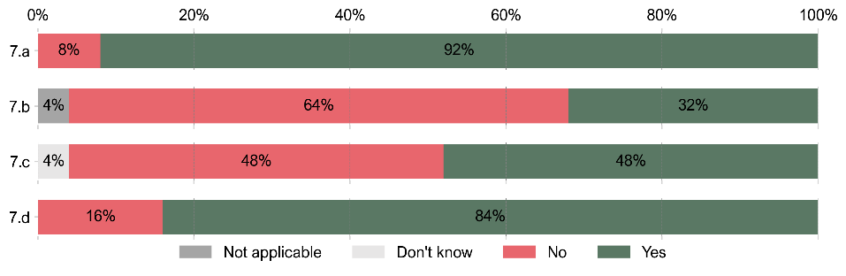

## Allocation of personnel, and roles and responsibilities

|  |
| --- |
| **10. To what extent do you agree or disagree with the following statements in respect of your local authority?** |
| a. There is an effective allocation of roles and responsibilities within the team(s) dealing with social care data.  b. The allocation of personnel to support analytical initiatives involving social care data is satisfactory. |

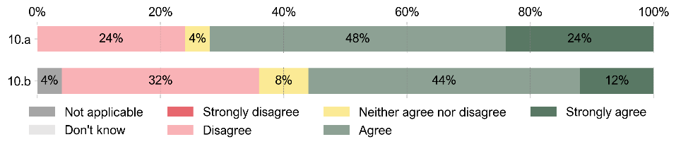

## Skills and capabilities

|  |
| --- |
| **12. To what extent do you agree with the following statements in respect of your local authority?** |
| a. There are enough people with a wide range of data and analysis expertise in our organisation readily available to support initiatives related to social care data.  b. The organisation has a clear understanding of the data and analytical skills needed to make the best use of social care data.  c. The organisation proactively seeks to upskill existing staff to meet upcoming data and analytical skills.  d. The organisation actively pursues the acquisition of external talent to strengthen data and analytical capabilities.  e. The data-related skills and capabilities within our social care teams align well with the organisation's strategic goals and objectives. |

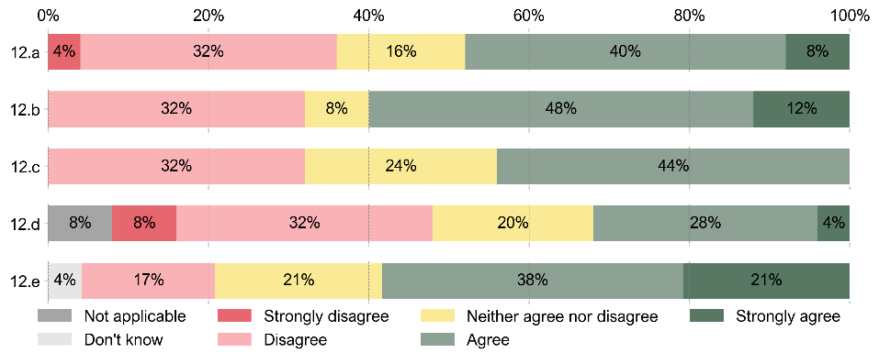

## Training for staff and social care professionals

|  |
| --- |
| **14. To what extent do you agree with the following statements in respect of your local authority?** |
| a. The resources (e.g., time, budget) dedicated to training staff and social care professionals regarding data and the use of data applications/systems are appropriate.  b. The organisation has structured data literacy programmes for staff and social care professionals.  c. The organisation collaborates with educational institutions or external partners to enhance data-related skills and capabilities within our social care teams.  d. The organisation has feedback mechanisms in place to assess the effectiveness of data skill development initiatives. |

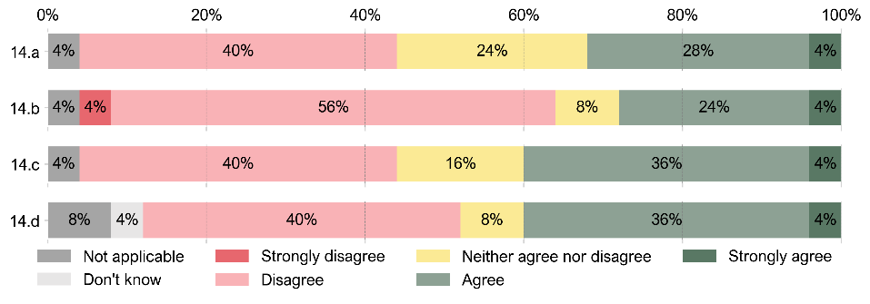

# Section 2: Digital records and data quality

## Service user core background information

|  |
| --- |
| **16. To what extent does your local authority collect data on service users’ core background information?** |

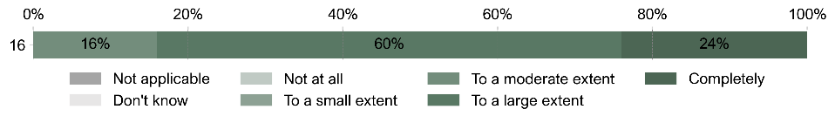

|  |
| --- |
| **17. To what extent is data collected on service users’ core background information ‘structured’ or ‘unstructured’?** |

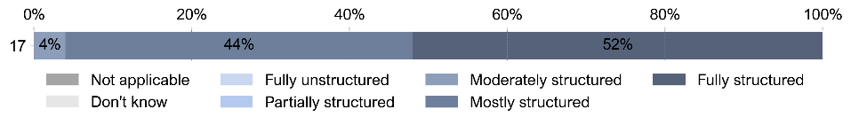

|  |
| --- |
| **18. To what extent do you agree with the following statements regarding the quality of data collected on service users’ core background information?** |
| a. The accuracy of data is regularly assessed and monitored to ensure that it reflects the most current and reliable information.  b. Data is consistently complete, with minimal gaps or missing information, enabling a comprehensive view of the individuals in care.  c. Data is standardised and consistent, ensuring seamless integration and efficient data exchange within the organisation.  d. Data is updated and shared in a timely manner, ensuring that all stakeholders have access to the most recent and relevant information. |

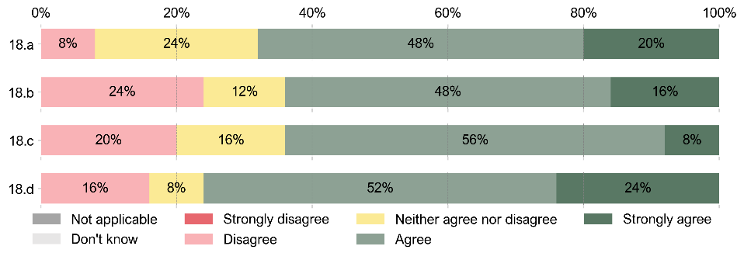

## Additional background information

|  |
| --- |
| **20. To what extent does your local authority collect data on service users’ additional background information?** |

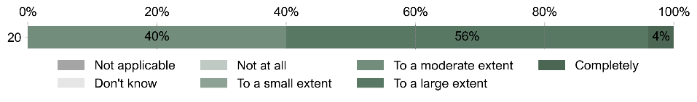

|  |
| --- |
| **21. To what extent is data collected on service users’ additional background ‘structured’ or ‘unstructured’?** |

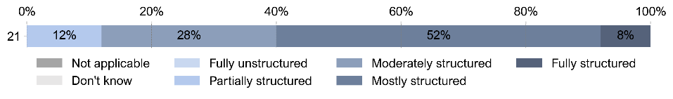

|  |
| --- |
| **22. To what extent do you agree with the following statements regarding the quality of data collected on service users’ additional background information?** |
| a. The accuracy of data is regularly assessed and monitored to ensure that it reflects the most current and reliable information.  b. Data is consistently complete, with minimal gaps or missing information, enabling a comprehensive view of the individuals in care.  c. Data is standardised and consistent, ensuring seamless integration and efficient data exchange within the organisation.  d. Data is updated and shared in a timely manner, ensuring that all stakeholders have access to the most recent and relevant information. |

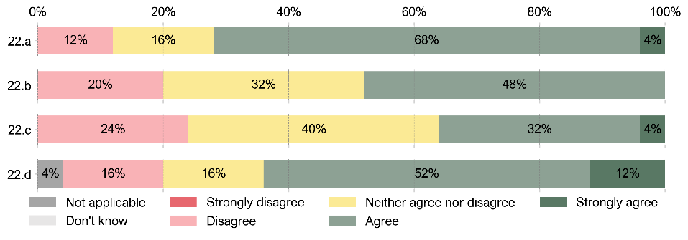

## Health and medical history

|  |
| --- |
| **24. To what extent does your local authority collect data on service users’ health and medical history?** |

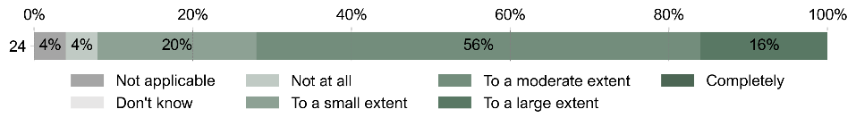

|  |
| --- |
| **25. To what extent is data collected on service users’ health and medical history ‘structured’ or ‘unstructured’?** |

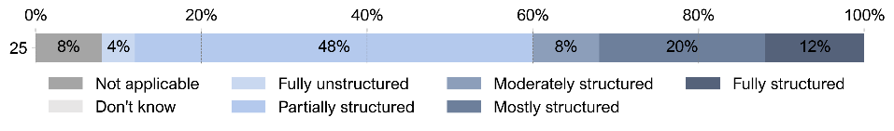

|  |
| --- |
| **26. Are service users’ NHS numbers routinely recorded on your electronic case management system?** |

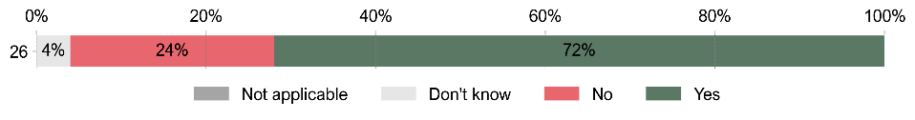

|  |
| --- |
| **27. If you answered yes to the question above – For approximately what share of users’ records are NHS numbers recorded?** |

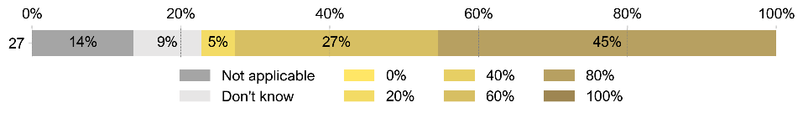

|  |
| --- |
| **28. To what extent do you agree with the following statements regarding the quality of data collected on service users’ health and medical history?** |
| a. The accuracy of data is regularly assessed and monitored to ensure that it reflects the most current and reliable information.  b. Data is consistently complete, with minimal gaps or missing information, enabling a comprehensive view of the individuals in care.  c. Data is standardised and consistent, ensuring seamless integration and efficient data exchange within the organisation.  d. Data is updated and shared in a timely manner, ensuring that all stakeholders have access to the most recent and relevant information. |

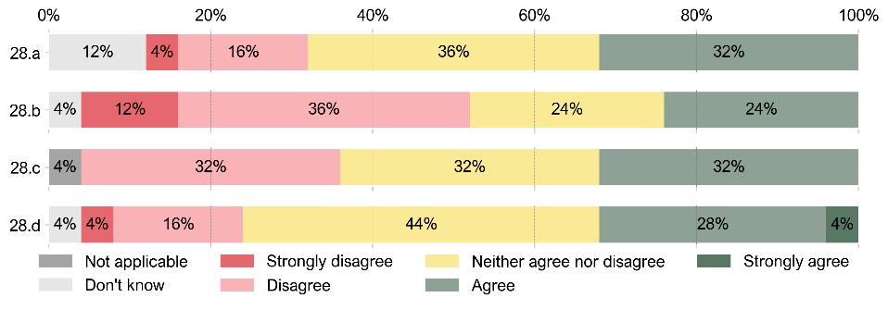

## Interaction with social care services

|  |
| --- |
| **30. To what extent does your local authority collect data on service users’ interaction with social care services?** |

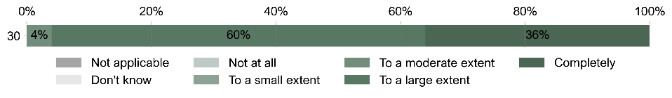

|  |
| --- |
| **31. To what extent is data collected on service users’ interactions with social care services ‘structured’ or ‘unstructured’?** |

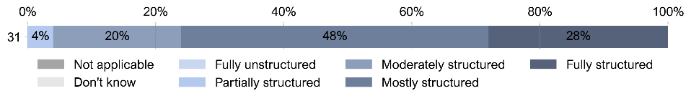

|  |
| --- |
| **32. To what extent do you agree with the following statements regarding the quality of data collected on service users’ interactions with social care services?** |
| a. The accuracy of data is regularly assessed and monitored to ensure that it reflects the most current and reliable information.  b. Data is consistently complete, with minimal gaps or missing information, enabling a comprehensive view of the individuals in care.  c. Data is standardised and consistent, ensuring seamless integration and efficient data exchange within the organisation.  d. Data is updated and shared in a timely manner, ensuring that all stakeholders have access to the most recent and relevant information. |

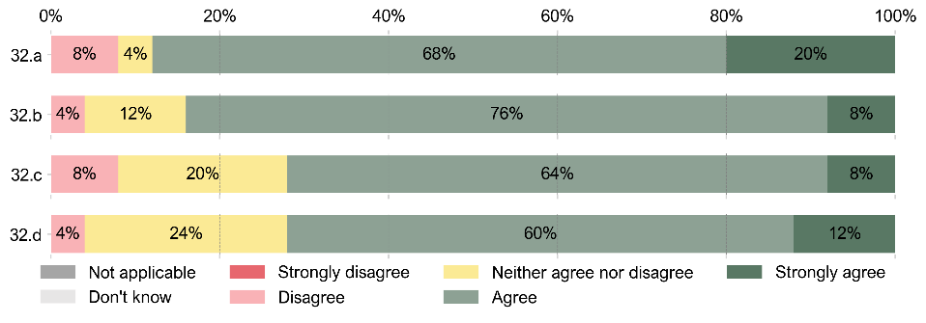

## Outcomes from interactions with social care services

|  |
| --- |
| **34. To what extent does your local authority collect data on service users’ outcomes?** |

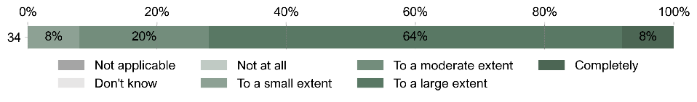

|  |
| --- |
| **35. To what extent is data collected on service users’ outcomes from ‘structured’ or ‘unstructured’?** |

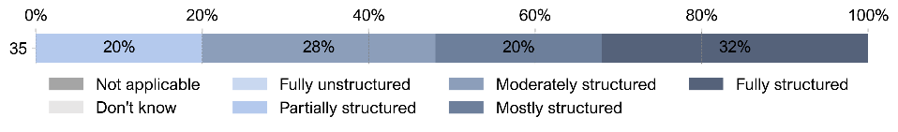

|  |
| --- |
| **36. To what extent do you agree with the following statements regarding the quality of data collected on service users’ outcomes?** |
| a. The accuracy of data is regularly assessed and monitored to ensure that it reflects the most current and reliable information.  b. Data is consistently complete, with minimal gaps or missing information, enabling a comprehensive view of the individuals in care.  c. Data is standardised and consistent, ensuring seamless integration and efficient data exchange within the organisation.  d. Data is updated and shared in a timely manner, ensuring that all stakeholders have access to the most recent and relevant information. |

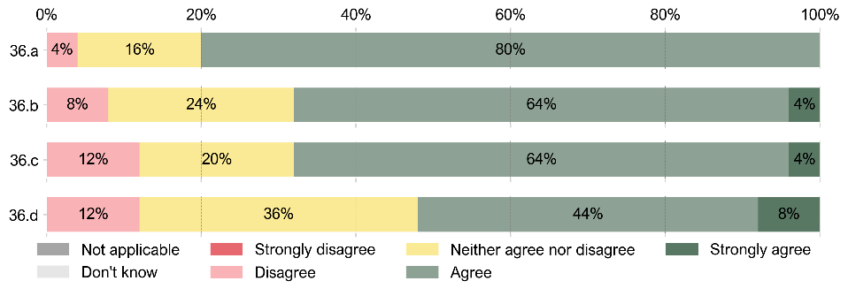

## Social care workforce

|  |
| --- |
| **38. To what extent does your local authority collect data on the social care workforce?** |

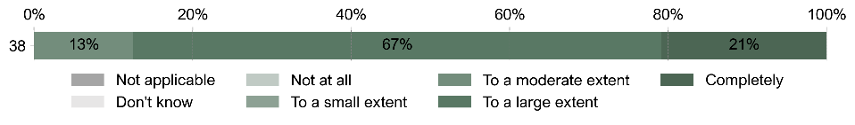

|  |
| --- |
| **39. To what extent is data collected on the social care workforce ‘structured’ or ‘unstructured’?** |

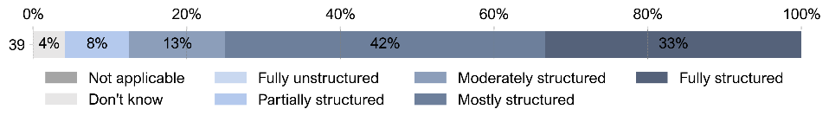

|  |
| --- |
| **40. To what extent do you agree with the following statements regarding the quality of data collected on the social care workforce?** |
| a. The accuracy of data is regularly assessed and monitored to ensure that it reflects the most current and reliable information.  b. Data is consistently complete, with minimal gaps or missing information, enabling a comprehensive view of the individuals in care.  c. Data is standardised and consistent, ensuring seamless integration and efficient data exchange within the organisation.  d. Data is updated and shared in a timely manner, ensuring that all stakeholders have access to the most recent and relevant information. |

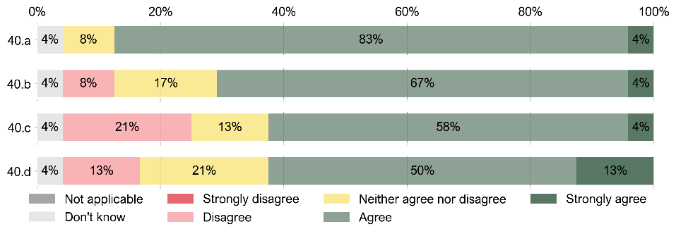

## Data quality assurance and improvement

|  |
| --- |
| **42. To what extent do you agree with the following statements regarding the organisational approaches for ensuring and improving data quality?** |
| a. The organisation adopts established metrics and tools to assess the quality of social care data, systematically evaluating the accuracy, completeness, consistency, and timeliness of social care data.  b. Routine data validation and cleaning processes are in place to ensure data quality, and these processes are well-documented to maintain data integrity.  c. The organisation has automated tools in place for data validation and cleaning, streamlining the process and reducing manual efforts.  d. Errors in social care data are promptly identified and rectified through clearly defined data error handling procedures, minimising the impact of inaccurate data.  e. The organisation employs standardised data formats and enforce their usage, ensuring that data consistency and compatibility are maintained across the organisation.  f. Challenges in adopting data standards are actively addressed, with strategies in place to overcome barriers to standardisation.  g. There are continuous initiatives to improve the quality of social care data, which include ongoing strategies to address and prevent data quality issues.  h. The organisation has dedicated employees or teams responsible for ensuring data quality, including data validation, cleaning, and ongoing improvement efforts.  i. There is a strong culture within the organisation regarding the importance of data quality, with training and awareness campaigns to promote the significance of high-quality social care data.  j. Staff members receive training and resources to enhance their data quality skills, supporting their ability to maintain and improve data quality. |

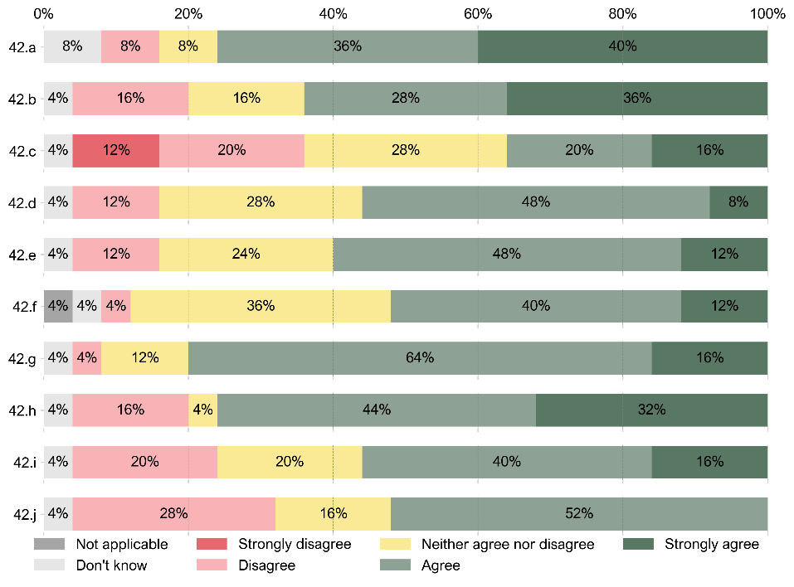

# Section 3: Systems and processes

## General information

|  |
| --- |
| **46. For how many years has your local authority been using the current case management system?** |

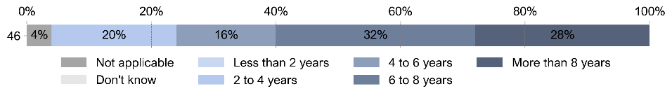

|  |
| --- |
| **47. For how many more years does your local authority have an existing commitment to use the current case management system?** |

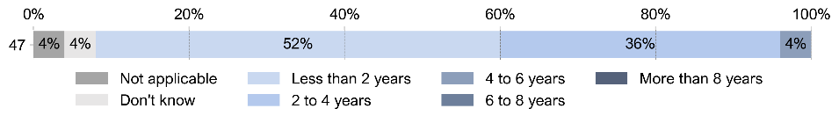

|  |
| --- |
| **48. Does your local authority have any plans to change the case management system in the future?** |

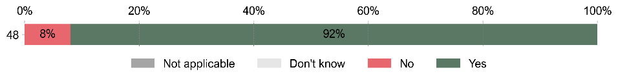

|  |
| --- |
| **49. How satisfied do you think your local authority is overall with the current electronic case management system?** |

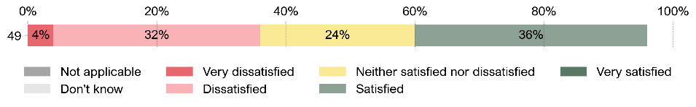

## Support to social care professionals

|  |
| --- |
| **51. To what extent do you agree with the following statements regarding the case management system’s features/capabilities in your local authority?** |
| a. Frontline workers have access to a consolidated view of client information, including care plans, medical history, and assessments, so they can make informed decisions during client interactions.  b. Frontline workers can easily create and update digital records and other related documentation directly at the point of care, reducing administrative burden and ensuring real-time data accuracy.  c. The system allows frontline workers to create and input digital records remotely (mobile working).  d. The system is equipped with efficient search functionality to access information quickly and easily.  e. The system provides tools for tracking client’s progresses towards goals, allowing frontline workers to continuously monitor and adjust care plan as needed.  f. The system includes a scheduling feature that allows frontline workers to view and manage their appointments, tasks, and visits, ensuring they stay organised and on top of their responsibilities.  g. The system provides real-time alerts and notifications for critical client updates or changes in care plans.  h. The system includes tools for collecting client feedback and conducting satisfaction surveys, which can help in improving the quality of care. |

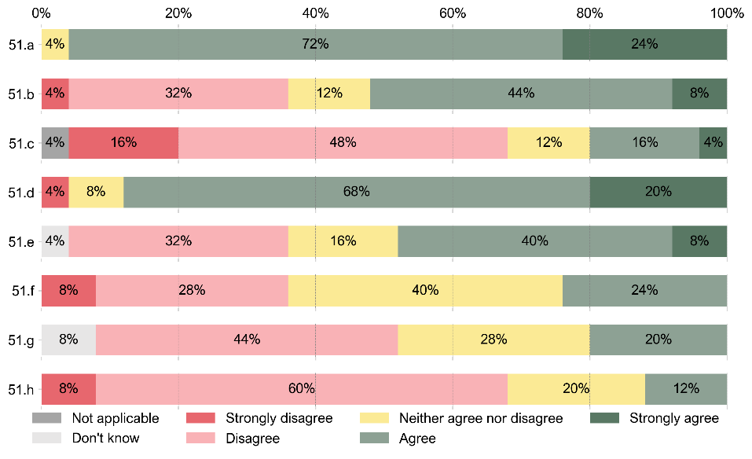

## Support to social care or data teams in your local authority

|  |
| --- |
| **53. To what extent do you agree with the following statements regarding the case management system’s features/capabilities in your local authority?** |
| a. The system offers a centralised data repository that consolidates all relevant information on social care clients and providers.  b. The system is provided with data validation tools to check for data accuracy and consistency, identify and correct data discrepancies, ensuring the reliability of information.  c. The system has integrated reporting capabilities that ensure compliance with regulatory requirements and reporting standards.  d. The system has integrated reporting capabilities that allow the creation of customised reports, dashboards and widgets according to the different needs of the organisation.  e. The system is provided with data analytics tools for in-depth analysis of social care data, enabling insights into trends, patterns, and outcomes.  f. The system facilitates collaboration and information sharing among different departments and agencies involved in social care service delivery.  g. The system keeps a detailed log of all changes made to client records for accountability and compliance purposes. |

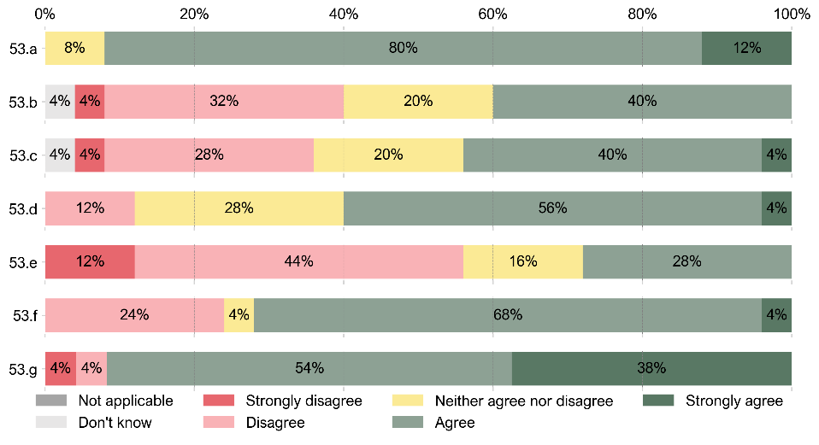

## Integration/interoperability with healthcare systems

|  |
| --- |
| **55. To what extent do you agree with the following statements regarding the case management system’s features/capabilities in your local authority?** |
| a. The system supports standardised data exchange protocols to facilitate interoperability with healthcare IT systems.  b. The system allows for the secure and efficient sharing of client data with external healthcare providers.  c. The system is compatible with common healthcare data formats and standards.  d. The system is adaptable to evolving healthcare interoperability requirements. |

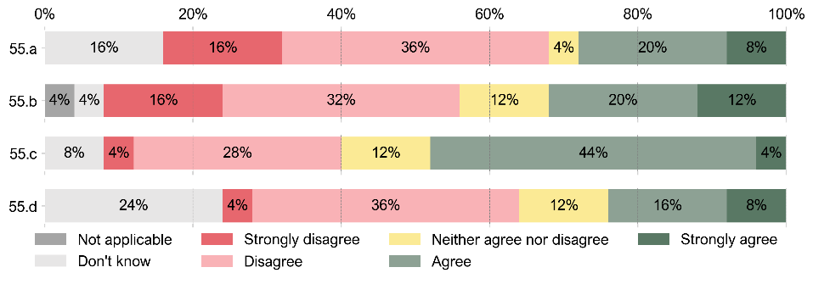

## Security and privacy protection

|  |
| --- |
| **57. To what extent do you agree with the following statements regarding the electronic case management system’s features and capabilities in your local authority?** |
| a. Data in the system is stored and transmitted securely, employing industry-standard encryption and security protocols.  b. The system is provided with robust data security features, including role-based access controls and audit trails, to ensure the confidentiality and integrity of client data.  c. The system provides tools that help the organisation meet data protection and privacy regulations, such as GDPR.  d. The system undergoes regular security assessments and penetration testing to identify and address vulnerabilities.  e. The system includes incident response and breach notification procedures to comply with data protection laws. |

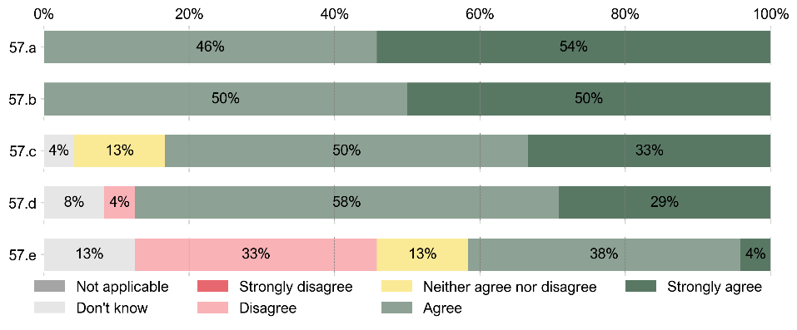

## Task and workflow automation

|  |
| --- |
| **63. To what extent do you agree with the following statements regarding the case management system’s features/capabilities in your local authority?** |
| a. The system automates routine tasks such as appointment scheduling, data entry, and report generation.  b. Workflow automation within the system streamlines processes and reduces manual intervention.  c. Automation and validation features are enabled in the system help improve efficiency and reduce the risk of errors.  d. The system supports the creation of custom automation rules and workflows to meet the specific needs of the organisation.  e. The system allows custom automation rules at a local rather than global level, giving organisations the flexibility to implement the rules as they fit their own organisation. |

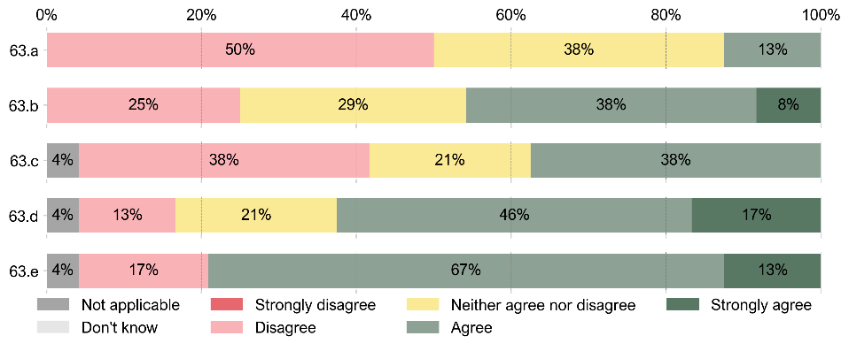

## Performance and scalability

|  |
| --- |
| **65. To what extent do you agree with the following statements regarding the case management system’s performance and scalability in your local authority?** |
| a. The system effectively handles high volumes of data and maintains optimal performance under heavy workloads.  b. The system supports a large number of concurrent users and ensures responsive performance during peak usage.  c. The system has mechanisms for proactive performance monitoring and optimisation.  d. The system can scale seamlessly to accommodate the growing needs of the organisation.  e. The system is rarely down or out of service.  f. Upgrades and patches are well managed by the supplier. |

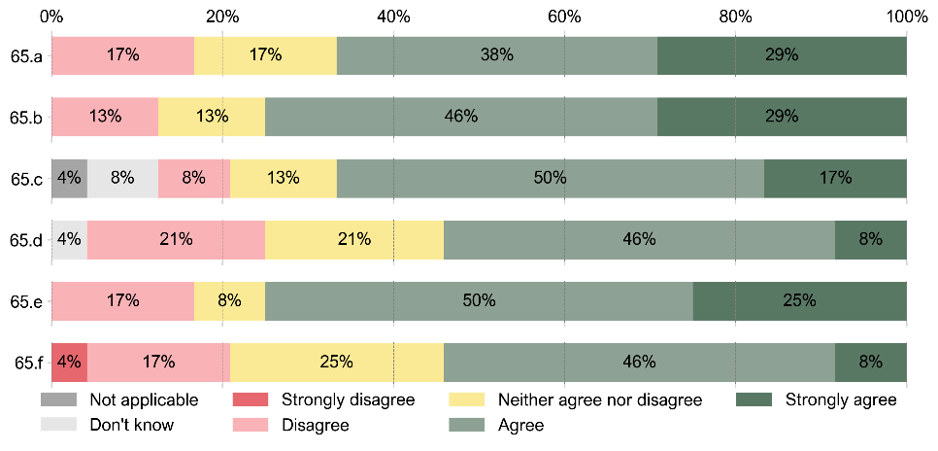

## Training and support

|  |
| --- |
| **67. To what extent do you agree with the following statements regarding the training and support available for staff and social care professionals to use the system in your local authority?** |
| a. The level of training available to staff and social care professionals to use the system is adequate, and ongoing training opportunities are provided to keep them up to date.  b. The organisation provides readily accessible user manuals and documentation to support staff in using the system effectively.  c. The system offers a user-friendly interface, reducing the learning curve for new users and minimising the need for extensive training.  d. Helpdesk support and a dedicated support team are available to assist users with any system-related issues. |

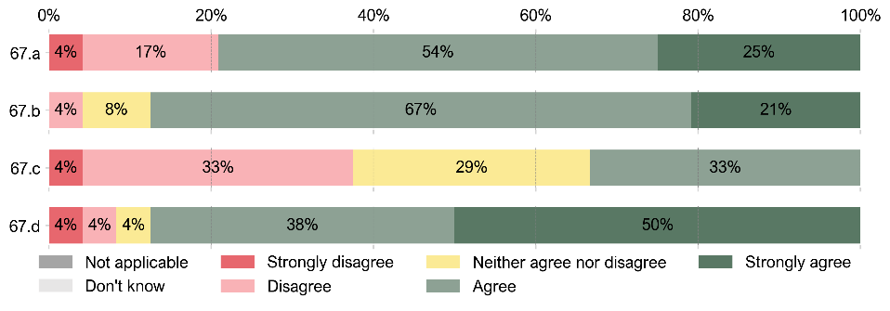

## Feedback collection and integration

|  |
| --- |
| **69. To what extent do you agree with the following statements regarding the possibility for users to provide feedback on the system’s usability and functionality in your local authority?** |
| a. There is an established system/protocol to provide feedback on the system's usability and functionality, and users are encouraged to provide input.  b. The feedback collected is systematically reviewed and integrated into the system's subsequent updates and improvements.  c. The organisation conducts periodic user surveys and feedback sessions to ensure continuous improvement.  d. Users are notified of changes and improvements made to the system based on their feedback. |

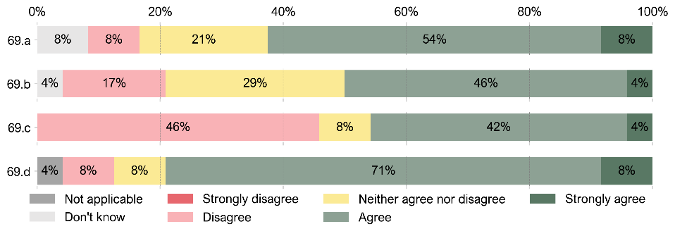

## Disaster recovery

|  |
| --- |
| **71. To what extent do you agree with the following statements regarding the measures in place to ensure data recovery and system availability in the event of a disaster or outage in your local authority?** |
| a. Regular data backups are executed and include off-site storage for disaster recovery.  b. A robust disaster recovery plan is in place, tested regularly, and includes failover mechanisms to safeguard client records.  c. Business continuity plans are tested and reviewed regularly.  d. The organisation has clear protocols for data recovery, including timelines for data restoration and service resumption.  e. The system has redundancy and failover mechanisms to ensure minimal downtime in case of system failures. |

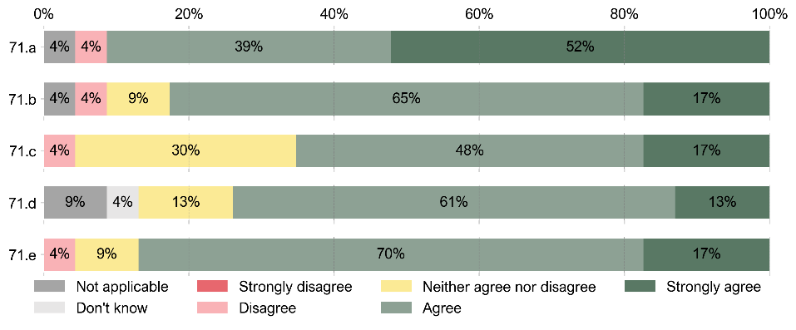

# Section 4: Uses of data

## Statutory compliance

|  |
| --- |
| **73. To what extent do you agree with the following statements regarding the uses of social care data within your local authority?** |
| Social care data supports the organisation’s efforts to meet statutory reporting requirements, ensuring transparency and compliance with regulatory standards. |

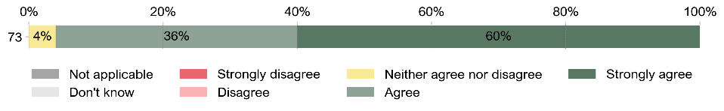

## Capacity planning and case allocation

|  |
| --- |
| **76. To what extent do you agree with the following statements regarding the uses of social care data within your local authority?** |
| a. The organisation has established data-driven processes for capacity planning based on social care data, ensuring that social care services are aligned with local demand.  b. Social care data is used to track the capacity and workload of care providers, ensuring that they are not overburdened and can deliver quality care to clients.  c. Social care data are used to prioritise and allocate cases effectively based on urgency and complexity.  d. The organisation leverages social care data to develop models that prioritise preventive measures and early interventions, reducing the need for reactive interventions. |

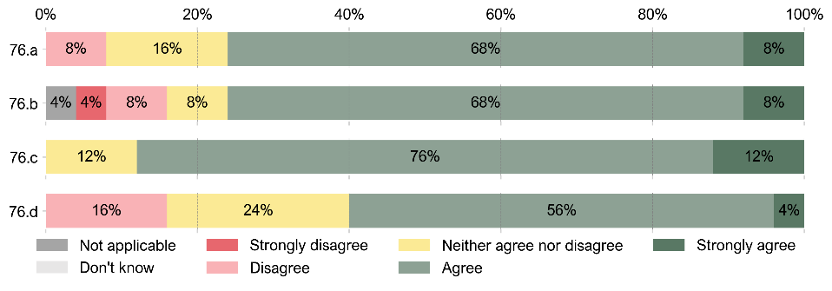

## Service effectiveness and improvement

|  |
| --- |
| **78. To what extent do you agree with the following statements regarding the uses of social care data within your local authority?** |
| a. The analysis of social care data enables the organisation to target interventions where they are most needed, ultimately enhancing the effectiveness of social care services.  b. Social care data is consistently used to monitor the quality of services delivered, ensuring they meet the desired standards.  c. Social care data is used to measure the efficiency and effectiveness of resource allocation, helping the continuous improvement of service provision.  d. Social care data is used to assess the effectiveness of early intervention and prevention programs. |

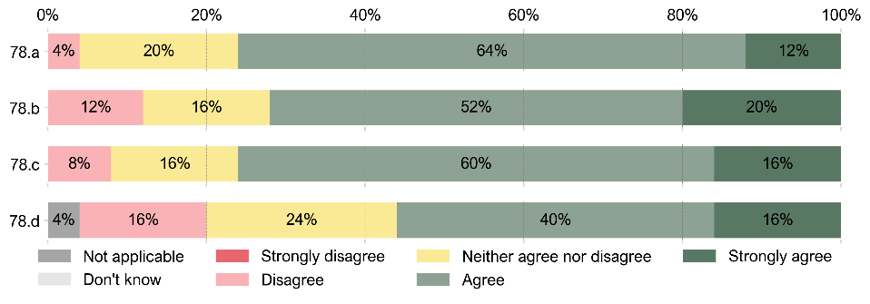

## Adaptability, capacity building and demand forecasting

|  |
| --- |
| **80. To what extent do you agree with the following statements regarding the uses of social care data within your local authority?** |
| a. Social care data plays a pivotal role in efforts to create an agile and responsive social care system that can adapt to changing demographics, evolving community needs, and the impact unexpected events.  b. Social care data is used in strategic planning to determine the need for changes to service provision and value-for-money.  c. The organisation utilises social care data to develop models that seek to predict future demand for social care services.  d. The organisation engages in scenario planning based on social care data to prepare for different potential futures and their impact on capacity requirements and sufficiency of service at a local level.  e. Social care data supports the organisation’s ability to plan for crisis scenarios, ensuring readiness for unexpected increases in demand. |

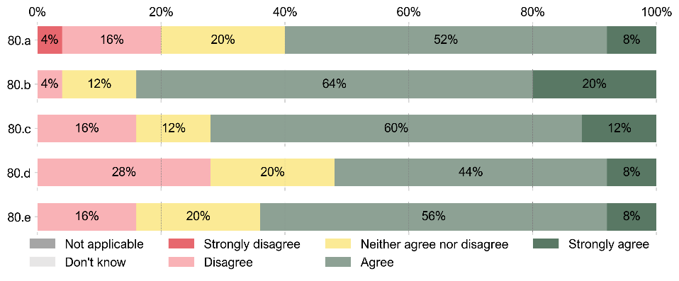

## Broader insights and evidence for policymaking

|  |
| --- |
| **82. To what extent do you agree with the following statements regarding the uses of social care data within your local authority?** |
| a. Social care data is used in conjunction with data from other areas such as education, housing, and benefits, enabling the organisation to gain comprehensive insights and improve cross-sector services.  b. The organisation collaborates with external research organisations to leverage social care data for comprehensive studies.  c. Operational and strategic development is backed up by evidence gathered locally and from high quality research.  d. The organisation uses linked-data research to better understand outcomes and/or impact of services on wellbeing.  e. Social care data is used to provide robust and credible evidence aimed to influence policy, fostering evidence-based decision-making for the benefit of our community. |

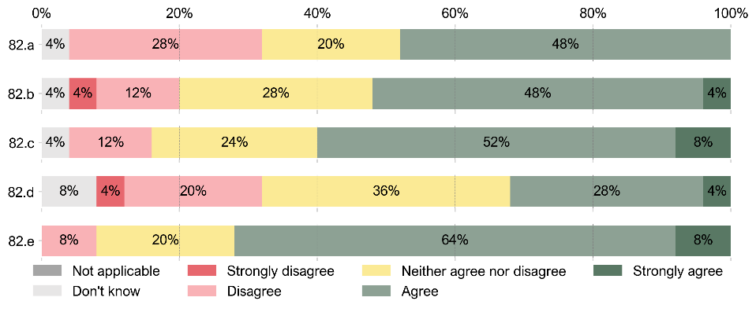

## Challenges and barriers to the use of data

|  |
| --- |
| **84. To what extent do you experience the following challenges to the use of social care data within your local authority?** |
| a. Insufficient data quality and accuracy leads to challenges in relying on social care data for decision-making.  b. Data gathered in multiple systems leads to inconsistency and ‘multiple versions of the truth’.  c. Incomplete or fragmented data records make it difficult to create a holistic view of individual cases and hindering comprehensive analysis.  d. Poor systems lead to low quality recordings with work sometimes needing to be repeated.  e. Staff have low confidence in the quality of data recorded on electronic care records.  f. Concerns about data privacy and confidentiality create barriers to using and sharing sensitive social care information.  g. Inadequate staff skills and training hinders the effective analysis and interpretation social care data.  h. Inadequate skills and permissions lead to data being ‘locked away’ from those who need it.  i. Lack of system functionality means that considerable time effort is taken to fulfil national data requirements (such as the Performance and Improvement Framework).  j. Lack of standardised data governance policies and procedures results in difficulties in managing and maintaining data integrity.  k. Inadequate technological infrastructure limits the ability to handle and process large volumes of data efficiently.  l. Challenges in standardising data formats and coding structures create difficulties in aggregating and comparing social care data across different systems and sources.  m. We don’t have the time and resources to do the work that really matters most.  n. Resistance to change within the organisational culture slows down the adoption of new data-driven practices and methodologies.  o. We do not have a culture of using data in decision making. |

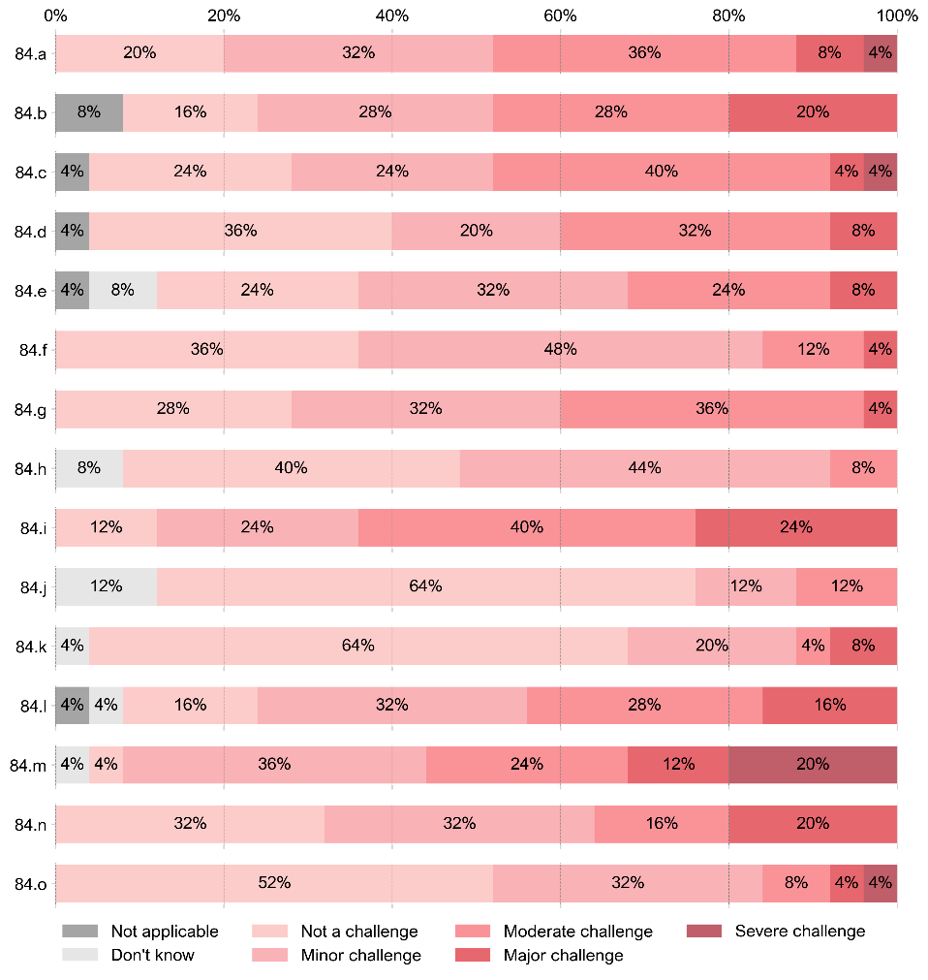

# Section 5: Data sharing

## Overview of the data sharing environment

|  |
| --- |
| **88. Which of the following organisations does your local authority currently share data with? Select all that apply.** |
| a. Welsh Government  b. Other local authorities  c. National Health Service (NHS)  d. Other public health bodies  e. Private sector social care providers  f. Academics and other research organisations  g. Voluntary and non-profit organisations  h. Police and law enforcement agencies  i. Legal services and courts  j. Employment and job placement agencies |

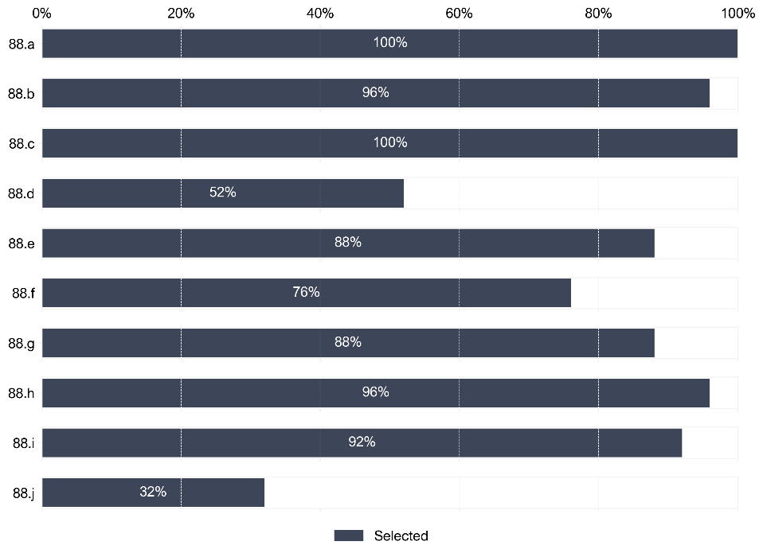

|  |
| --- |
| **89. For which of the following purposes is your local authority sharing data with other organisations? Select all that apply.** |
| a. To comply with statutory requirements  b. To understand the medical history of service users  c. To inform internal research projects  d. To inform the research projects of external organisations  e. To support the construction of shared data resources (e.g., SAIL Databank)  f. To evaluate social care initiatives  g. To coordinate emergency and crisis response  h. To inform early intervention and prevention strategies  i. To improve the integration of social care with other public services |

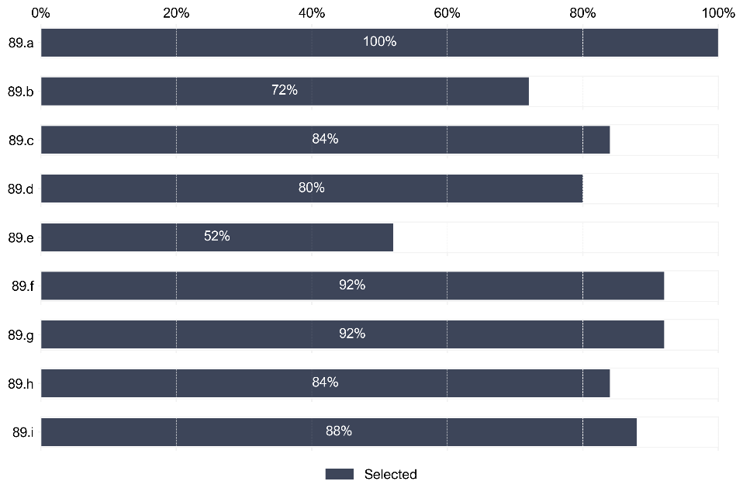

|  |
| --- |
| **90. Is your local authority current signed up to the Wales Accord on the Sharing of Personal Information (WASPI)?** |

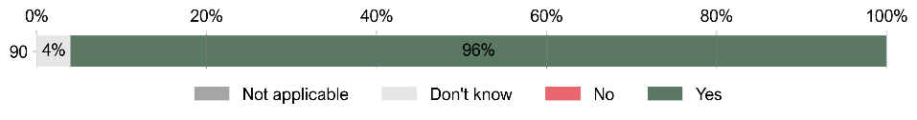

## Data sharing in practice

|  |
| --- |
| **92. To what extent do you agree with the following statements regarding the sharing of social care data with external entities in your local authority?** |
| a. The organisation has a clear understanding of the challenges and obstacles related to sharing social care data with external entities.  b. The organisation has well-defined and documented internal data governance protocols, policies, and procedures for sharing social care data with external entities.  c. The organisation has designated roles and responsibilities for managing and overseeing data sharing activities.  d. There is a strong culture of data sharing within the organisation, promoting collaboration and information exchange with external entities.  e. The organisation has robust measures in place to ensure the security and privacy of social care data when shared with external entities.  f. The organisation follows standardised data formats and interoperability standards to improve data compatibility when sharing information with external entities.  g. Advanced technologies and systems have been implemented to facilitate the sharing of social care data.  h. The organisation is actively investing in technologies and systems to improve the efficiency of data sharing with external entities.  i. The organisation has established partnerships and collaborations with healthcare systems and external organisations to enhance data sharing efforts.  j. The organisation actively seeks feedback from recipients of shared data to improve the quality and usefulness of the information exchanged. |

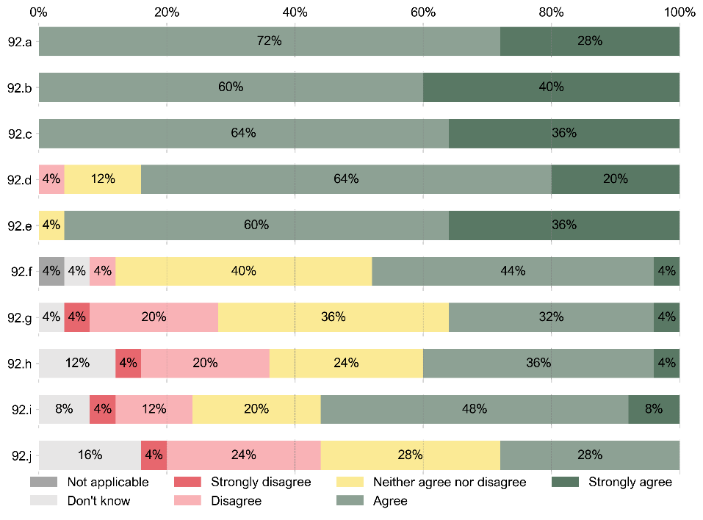

## Standardised data sharing

|  |
| --- |
| **94. Is there a capability for physical data exchange between different software systems within your local authority?** |

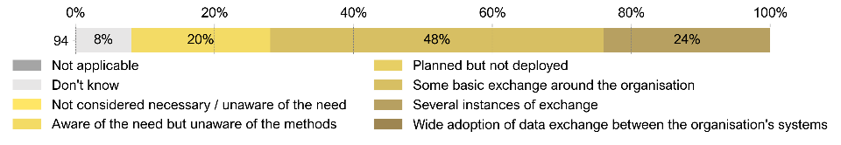

|  |
| --- |
| **95. Is there a capability for physical data exchange with other organisations (3rd parties) within your local authority?** |

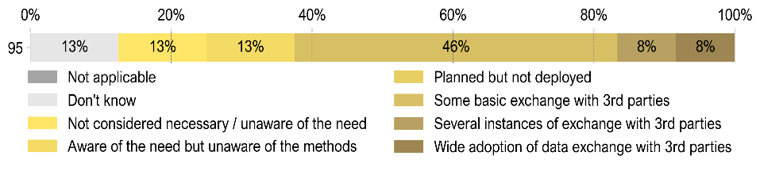

|  |
| --- |
| **96. Where data is exchanged, it is typically… Select all that apply.** |
| a. Manual (e.g., typed or cut and pasted)  b. Automatically generated exchanged data  c. Unstructured data exchange (e.g., Word document, PDF)  d. Semi-unstructured (e.g., Excel)  e. Basic structure (e.g., CSV or other tabular format)  f. Fully structured (e.g., XML, JSON, or other complex/hierarchical format)  g. Standardised structure (e.g., HL7, CDISC)  h. Exchange sent by manual means (e.g., email, FTP upload)  i. Automatic - message transmit/receive based  j. System to system direct (e.g., software exposes API, or REST)  k. Don’t know  l. Not applicable |

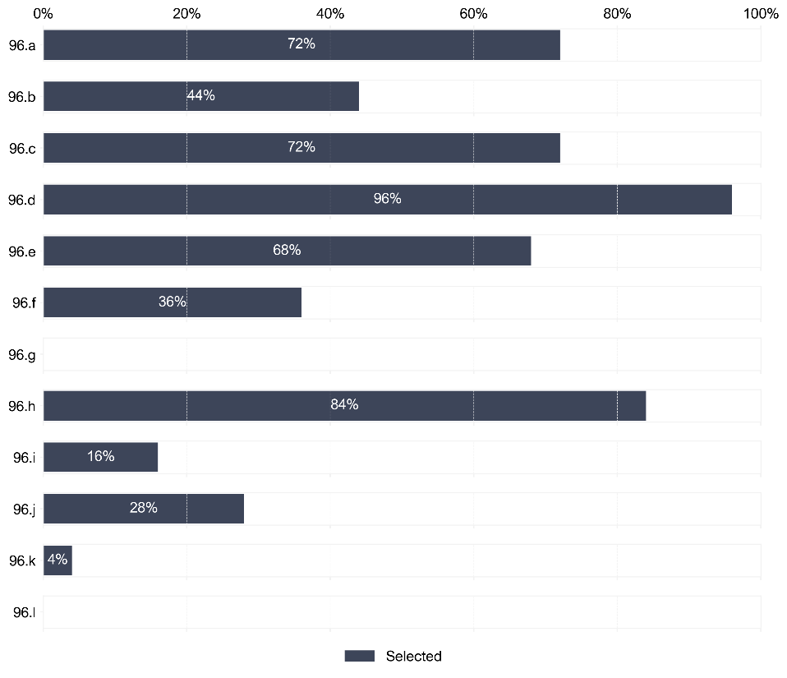

|  |
| --- |
| **97. What are the known barriers to facilitating standardised data exchange within your local authority? Select all that apply.** |
| a. Lack of awareness of the options for standardisation  b. Insufficient knowledge or training  c. Information governance issues (e.g., lack of data sharing agreements)  d. Not prioritised / funded  e. Lack of infrastructure / equipment / software |

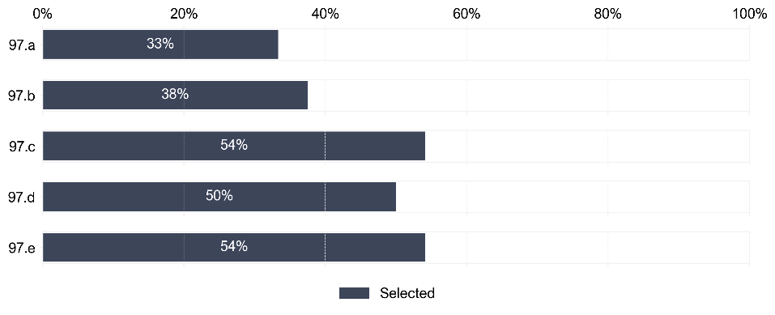

## Challenges and barriers to data sharing

|  |
| --- |
| **99. To what extent do you experience the following challenges to sharing social care data within your local authority?** |
| a. The absence of common identifiers creates challenges in linking different datasets, preventing the joining of data from different sources.  b. Inconsistent definitions of data fields across organisations hinder effective data sharing, leading to potential misinterpretation and errors.  c. Different systems in use across different entities pose obstacles to uniform data sharing practices, complicating the exchange of information with external organisations.  d. Insufficient awareness within the organisation about the advantages of sharing social care data may hinder the emergence or success of data sharing initiatives.  e. Inadequate resources, including funding, skilled personnel and technology, may hinder the ability to support effective and secure data sharing practices within the local authority.  f. The absence of a pervasive culture promoting data sharing limits collaboration and information exchange within the organisation and with external entities.  g. Navigating complex legal frameworks and ensuring compliance with data protection regulations (e.g., GDPR) can pose challenges to sharing social care data.  h. Ensuring the quality of shared data is an ongoing challenge, with potential inconsistencies and inaccuracies undermining the reliability of information exchange.  i. Challenges in effective communication and collaboration between different departments or units within the local authority may hinder seamless data sharing.  j. Lack of standardised data governance practices across various organisations makes it difficult to establish consistent protocols for data sharing.  k. Concerns that the act of sharing data may expose the local authority to reputational risk may act as a significant deterrent, discouraging the willingness to engage in data sharing. |

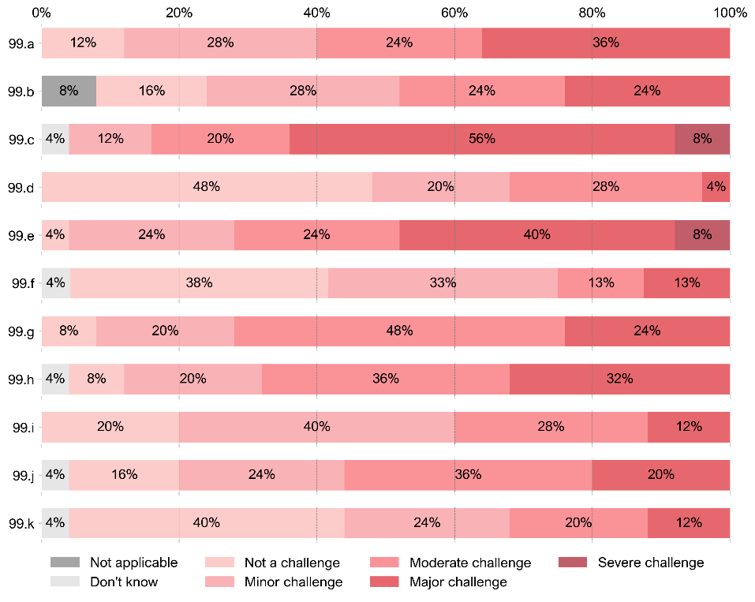

# Section 6: Leadership, strategy and culture

## Data culture and leadership

|  |
| --- |
| **101. To what extent do you agree with the following statements regarding data culture and leadership in relation to your local authority?** |
| a. Data is a top organisational priority, recognised as crucial for effective social care services.  b. Data strategy, principles, and policies are integrated into the core fabric of the organisation, guiding daily operations.  c. Leadership consistently communicates the importance of data in achieving overarching organisational goals.  d. There is widespread awareness across the organisation regarding the pivotal role of data, extending beyond the data teams to encompass most members of the organisation.  e. There is knowledge within the organisation of what data can be shared and how, ensuring that staff have the confidence to action data requests effectively. |

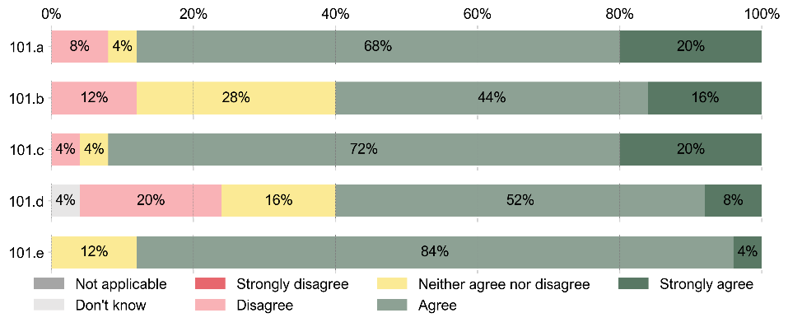

## Data strategy and stakeholder engagement

|  |
| --- |
| **103. To what extent do you agree with the following statements regarding data strategy and stakeholder engagement in relation to your local authority?** |
| a. The organisation has a formal, well-documented data strategy or plan for social care data.  b. Regular assessments and updates to the data strategy are conducted, reflecting evolving social care needs and stakeholder input, to maintain its relevance and effectiveness.  c. Stakeholders, including service users, care providers, and other relevant parties, are actively engaged to provide input on data strategies and priorities.  d. There are formal mechanisms in place to ensure that the voices and needs of stakeholders are considered in data-related decision-making. |

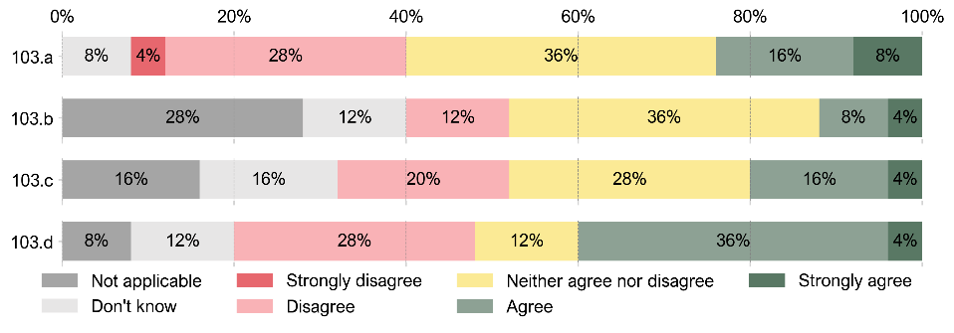

## Data-related collaboration and innovation

|  |
| --- |
| **105. To what extent do you agree with the following statements regarding data-related collaboration and innovation for your local authority?** |
| a. The organisation actively seeks data-related collaborations with external partners to harness the full potential of social care data and support innovative projects.  b. Leadership fosters a culture of innovation and experimentation in the use of social care data to enhance services and outcomes.  c. The organisation employs pilots, trials, and research to gather robust evidence for what works in social care data management and service improvement.  d. The organisation actively participates in collaborative data-sharing initiatives with other organisations to enhance overall social care data capabilities. |

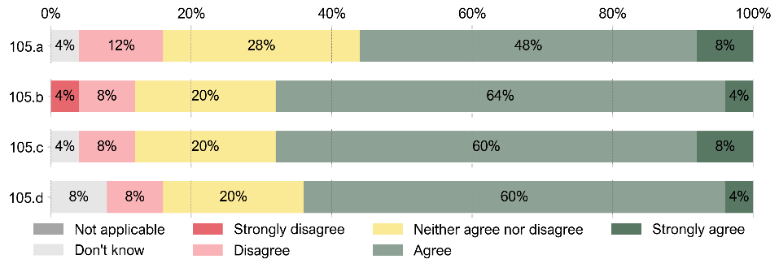



lma Economics back cover information. 
UK address: 43 Tanner Street, SE1 3PL, London, UK, +44 20 8133 3192.
GR address: Ifigenias 9, 14231, Athens, GR, +30 21 2104 7902. 

Copyright © 2023 All rights reserved.
Company Number 09391354, VAT Number GB208923405, Registered in England and Wales

1. Welsh Government (2018). ‘A healthier Wales: long term plan for health and social care’.   
   Available at: <https://www.gov.wales/healthier-wales-long-term-plan-health-and-social-care>
2. Welsh Government (2023). ‘Digital and data strategy for health and social care in Wales’.   
   Available at: <https://www.gov.wales/digital-and-data-strategy-health-and-social-care-wales-html>
3. More information available at: <https://www.gov.uk/government/publications/hmcts-data-strategy-december-2021> (accessed 23rd May 2024)
4. More information available at: <https://publichealthscotland.scot/services/national-data-catalogue/data-dictionary/a-to-z-of-data-dictionary-terms/> (accessed 23rd May 2024)
5. More information available at: <https://www.digihealthcare.scot/our-work/digital-maturity/> (accessed 23rd May 2024)